**Anjuman-I-Islam’s**

**M.H. Saboo Siddik Polytechnic**



**Subject name:** WBP(22619).

**Department:** Computer Engineering.

**Semester:** VIth

**Micro Project Title:** Art Gallery Management System

**Year: 2022-23**

**Prepared By:**

Names of Team Members with Roll Nos.

1. (20427) Khan Ramsha.
2. (20428) Khan Tariq.
3. (20429) Khan Zubia.
4. (20438) Qureshi Umme Atiya

**Under the guidance of:** Prof. Mohammed Zaid



**MAHARASHTRA STATE**

**BOARD OF TECHNICAL EDUCATION**

**Certificate**

This is to certify that Ms. **Khan Rasmsha** Roll No. **20427** of Sixth Semester of Diploma in **Computer Engineering** of Institute **M. H. Saboo Siddik Polytechnic (**Code: 0002) has successfully completed Micro-project work in subject **Web Based Programming (22619)** for the academic year **2022**-**2023** as prescribed in the I-Scheme Curriculum.

Place: **Mumbai** Enrollment No:200020195

Date: Exam. Seat No:

**Signature Signature Signature**

**Project Guide H.O.D Principal**



SEAL OF INSTITUTE





**MAHARASHTRA STATE**

**BOARD OF TECHNICAL EDUCATION**

**Certificate**

This is to certify that Mr. **Khan Tariq** Roll No. **20428** of Sixth Semester of Diploma in **Computer Engineering** of Institute **M. H. Saboo Siddik Polytechnic (**Code: 0002) has successfully completed Micro-project work in subject **Web Based Programming (22619)** for the academic year **2022**-**2023** as prescribed in the I-Scheme Curriculum.

Place: **Mumbai** Enrollment No:200020197

Date: Exam. Seat No:

**Signature Signature Signature**

**Project Guide H.O.D Principal**



SEAL OF INSTITUTE





**MAHARASHTRA STATE**

**BOARD OF TECHNICAL EDUCATION**

**Certificate**

This is to certify that Ms. **Khan Zubia** Roll No. **20429** of Sixth Semester of Diploma in **Computer Engineering** of Institute **M. H. Saboo Siddik Polytechnic (**Code: 0002) has successfully completed Micro-project work in subject **Web Based Programming (22619)**for the academic year **2022**-**2023** as prescribed in the I-Scheme Curriculum.

Place: **Mumbai** Enrollment No:200020199

Date: Exam. Seat No:

**Signature Signature Signature**

**Project Guide H.O.D Principal**



SEAL OF INSTITUTE





**MAHARASHTRA STATE**

**BOARD OF TECHNICAL EDUCATION**

**Certificate**

This is to certify that Ms. **Qureshi Umme Atiya** Roll No. **20438** of Sixth Semester of Diploma in **Computer Engineering** of Institute **M. H. Saboo Siddik Polytechnic (**Code: 0002) has successfully completed Micro-project work in subject **Web Based Programming (22619)**for the academic year **2022**-**2023** as prescribed in the I-Scheme Curriculum.

Place: **Mumbai** Enrollment No:200020196

Date: Exam. Seat No:

**Signature Signature Signature**

**Project Guide H.O.D Principa**



SEAL OF INSTITUTE



**Acknowledgment**

We wish to express our profound gratitude to our guide Mr. Mohammed Zaid who guided us endlessly in the framing and completion of the micro project. He guided us on all the main points in that micro project. We are indebted to his constant encouragement, cooperation, and help. It was his enthusiastic support that helped us in overcoming various obstacles in the micro-project.

We are also thankful to our Principal, HOD, faculty members and classmates of Computer Engineering department for extending their support and motivation in the completion of this micro-project.

Names of Team Members with Roll Nos.

1. (20427) Khan Ramsha.
2. (20428) Khan Tariq.
3. (20429) Khan Zubia.
4. (20438) Qureshi Umme Atiya.

**Annexure-I**

**Micro-Project Proposal**

Art Gallery Management System.

1. **Aims/Benefits of the Micro-Project.**

Micro projects are small-scale initiatives that aim to achieve specific goals within a short period and budget. They offer several benefits, including skill development, community engagement, and positive impact on a local level, while allowing for experimentation, innovation, and flexibility in project implementation.

1. **Course Outcomes Addressed.**

a) Develop program using control statement.

b) Perform operations based on arrays and graphics.

c) Develop programs by applying various object oriented concepts.

d) Use form controls with validation to collect user's input.

e) Perform database operations in PHP.

1. **Proposed Methodology*.***

1. To search the information about the project. (Collect relevant data from different sources (books/internet/market/suppliers/experts and others through surveys/interviews etc.).

2. To collect all relevant content / materials to complete the project.

3. To prepare the report of micro project.

4. To deliver presentation/ appear for viva-voice.

5. Discussion of topic with guide and group members.

6. Literature survey.

7. Submission of project proposal. (Annexure I).

8. Collection of data / information.

9. Analysis of data / information.

10. Compilation of content.

11. Rough draft submission.

12. Editing and reviewing the content.

13. Weekly progress report submission.

14. Final draft submission.

15. Viva Voce / Delivery of presentation

1. **Action Plan**.

|  |  |  |  |  |  |
| --- | --- | --- | --- | --- | --- |
| **Sr. No** | **Week** | **Details of activity** | **Planned Start date** | **Planned Finish date** | **Name of Responsible Team Members** |
| 1 | 1 & 2 | Discussion and finalization of the topic. | 02/02/23 | 16/02/23 | Ramsha |
| 2 | 3 | Preparation of the abstract | 16/02/23 | 23/02/23 | Tariq |
| 3 | 4 | Literature review | 23/02/23 | 02/03/23 | Ramsha |
| 4 | 5 | Submission of micro project proposal | 02/03/23 | 09/03/23 | Zubia |
| 5 | 6 | Collection of the information on the topic. | 09/03/23 | 16/03/23 | Atiya |
| 6 | 7 | Collection of all relevant content / materials for the execution of the project. | 16/03/23 | 23/03/23 | Zubia |
| 7 | 8 | Discussion and submission of outline of the project. | 23/03/23 | 30/03/23 | Tariq |
| 8 | 9 | Analysis/execution of collected data/information and Preparation of prototypes/drawings/charts/graphs/ tables/models/circuits/programs etc. | 30/03/23 | 06/04/23 | Ramsha |
| 9 | 10 | Compilation of contents of project | 06/04/23 | 13/04/23 | Zubia |
| 10 | 11 | Compilation of weekly progress report | 13/04/23 | 20/04/23 | Atiya |
| 11 | 12 | Preparation of the project report | 20/04/23 | 27/04/23 | Atiya |
| 12 | 13 | Viva Voce / Delivery of presentation. | 14/05/23 | 14/05/23 | Tariq |

1. **Resources Required.**

|  |  |  |  |  |
| --- | --- | --- | --- | --- |
| **Sr No.** | **Name of Resource/ Material** | **Specifications** | **Quantity** | **Remarks** |
| 1 | Computer System | HP pavilion amd Ryzen 5  Ram 8 gb | 1 |  |
| 2 | Xampp | 11.0.13+0-b1751.21-8125866 amd64 | 1 |  |
| 3 | VS Code | - | 1 |  |

**Names of Team Members with Roll Nos.**

1. (20427) Khan Ramsha.
2. (20428) Khan Tariq.
3. (20429) Khan Zubia.
4. (20438) Qureshi Umme Atiya.

Annexure - II

**Micro-Project Report**

**Art Gallery Management System**

1. **Rationale**

The aim of this micro project is to design and develop a web application for Art Gallery Management System is to streamline and automate various administrative and operational tasks involved in running an art gallery. It provides a centralized platform that facilitates the efficient management of artwork, artists, exhibitions, sales, and other related activities.

1. **Aims/Benefits of the Micro-Project:**
2. Artwork Cataloging and Inventory Management: Art galleries typically deal with a large number of artworks. An Art Gallery Management System allows the gallery to catalog and organize its artwork collection, including details such as artist name, title, medium, dimensions, acquisition date, and provenance. It helps to maintain an accurate inventory of artwork, simplifies the process of adding new acquisitions, and ensures efficient tracking of artworks within the gallery.
3. Artist Management: Art galleries work with various artists, and an Art Gallery Management System helps in managing artist information, including contact details, biographies, artwork portfolios, and exhibition histories. It simplifies the process of managing artist contracts, agreements, and commission tracking.
4. Exhibition Planning and Scheduling: Galleries often host multiple exhibitions throughout the year. An Art Gallery Management System allows the gallery to plan and schedule exhibitions, including setting up exhibition spaces, assigning artwork to specific exhibitions, and managing exhibition timelines. It helps in coordinating logistics, planning exhibition openings, and tracking the availability and movement of artworks.
5. Sales and Inventory Tracking: Art Gallery Management Systems provide features for managing sales transactions, including artwork pricing, sales records, and invoices. It enables galleries to track sales, generate sales reports, and manage client information. Integration with a customer relationship management (CRM) system allows galleries to maintain relationships with collectors and track their preferences and purchase history.
6. Financial Management: Art galleries have financial aspects that need to be managed, such as budgeting, expenses, and revenue tracking. An Art Gallery Management System can provide tools to manage financial data, generate financial reports, and track expenses associated with exhibitions, marketing, and other operational costs. It simplifies financial analysis and aids in decision-making.
7. Marketing and Communication: Effective marketing and communication are crucial for art galleries to attract visitors and promote their exhibitions and artists. An Art Gallery Management System may include features for managing mailing lists, sending out newsletters, tracking marketing campaigns, and integrating with social media platforms. It helps galleries reach a wider audience and engage with art enthusiasts.
8. Analytics and Reporting: An Art Gallery Management System can provide analytical tools to generate reports and insights on various aspects, such as artwork popularity, sales trends, visitor demographics, and exhibition success rates. This data helps galleries make informed decisions, optimize operations, and identify areas for improvement.
9. **Course Outcomes Achieved:**

a) Develop program using control statement.

b) Perform operations based on arrays and graphics.

c) Develop programs by applying various object oriented concepts.

d) Use form controls with validation to collect user's input.

e) Perform database operations in PHP.

1. **Literature Review :**

Some key aspects that may be covered in the literature on Art Gallery Management Systems include:

1. Overview of Art Gallery Management Systems: The literature may provide an overview of the purpose, functionalities, and benefits of Art Gallery Management Systems. It may discuss how these systems streamline various tasks involved in art gallery operations, improve efficiency, and enhance visitor experience.
2. Technical Features and Requirements: The literature may delve into the technical aspects of Art Gallery Management Systems, discussing the software and hardware requirements, database management, user interfaces, and integration with other systems (such as accounting software or CRM systems).
3. Artwork Cataloging and Inventory Management: Scholars may explore the importance of artwork cataloging and inventory management within art galleries. They may discuss how Art Gallery Management Systems facilitate the organization, documentation, and tracking of artwork, including details such as artist information, provenance, dimensions, and valuation.
4. Artist Management and Exhibition Planning: The literature may cover the functionalities related to artist management and exhibition planning. It may discuss how Art Gallery Management Systems assist in managing artist information, contracts, and portfolios, as well as in planning and scheduling exhibitions, assigning artworks, and coordinating logistics.
5. Sales and Financial Management: Scholars may explore the features and benefits of Art Gallery Management Systems in the context of sales and financial management. They may discuss how these systems help galleries track sales, generate invoices, manage client information, and analyze financial data, ultimately aiding in decision-making and financial planning.
6. Marketing and Communication: The literature may touch upon the role of Art Gallery Management Systems in marketing and communication. It may discuss how these systems facilitate targeted marketing campaigns, manage mailing lists, track customer preferences, and integrate with social media platforms to promote exhibitions and engage with art enthusiasts.
7. Evaluation and Case Studies: Some literature may present case studies or evaluations of specific Art Gallery Management Systems. These studies may analyze the implementation process, system performance, user satisfaction, and the overall impact on gallery operations.
8. **Actual Methodology Followed**

1. Define project scope and objectives

2. Conduct requirements gathering

3. Design system architecture and user interface

4. Develop prototype and get feedback

5. Implement features and functionalities

6. Test system for functionality and usability

7. Incorporate user feedback and make necessary revisions

8. Deploy system and ensure compatibility with relevant platforms

9. Continuously monitor and update the system to improve performance and address any issues.

10. Finalizing the report and present

1. **Actual Resources Used:**

|  |  |  |  |  |
| --- | --- | --- | --- | --- |
| **Sr No.** | **Name of Resource/ Material** | **Specifications** | **Quantity** | **Remarks** |
| 1 | Computer System | HP pavilion amd Ryzen 5  Ram 8 gb | 1 |  |
| 2 | Xampp | - | 1 |  |
| 3 | VS Code | - | 1 |  |

1. **Outputs of the microproject**
   1. **Introduction to Art Gallery Management System:**

An Art Gallery Management System is a software application designed to streamline and automate various administrative and operational tasks involved in running an art gallery. It provides a centralized platform that facilitates efficient management of artwork, artists, exhibitions, sales, and other related activities.

Art galleries often face challenges in organizing and managing their vast collections of artworks, coordinating exhibitions, tracking sales, and maintaining artist information. Manual processes can be time-consuming, error-prone, and inefficient. An Art Gallery Management System addresses these challenges by providing a digital solution that simplifies and enhances gallery operations.

The primary purpose of an Art Gallery Management System is to enable galleries to catalog and organize their artwork collections. This includes capturing details such as artist names, titles, mediums, dimensions, acquisition dates, and provenance. The system allows galleries to maintain an accurate inventory of their artworks, simplifies the process of adding new acquisitions, and ensures efficient tracking of artworks within the gallery.

Additionally, an Art Gallery Management System assists in managing artist information. It allows galleries to store and organize artist biographies, contact details, artwork portfolios, and exhibition histories. The system simplifies the management of artist contracts, agreements, and commission tracking.

Exhibition planning and scheduling are also essential components of an Art Gallery Management System. Galleries can use the system to plan and schedule exhibitions, set up exhibition spaces, assign artworks to specific exhibitions, and manage exhibition timelines. This functionality helps galleries coordinate logistics, plan exhibition openings, and track the availability and movement of artworks.

Sales and inventory tracking are streamlined through an Art Gallery Management System. The system allows galleries to manage sales transactions, including artwork pricing, sales records, and invoices. It enables galleries to track sales, generate sales reports, and manage client information. Integration with a customer relationship management (CRM) system allows galleries to maintain relationships with collectors and track their preferences and purchase history.

Financial management is another key aspect addressed by an Art Gallery Management System. The system provides tools to manage financial data, generate financial reports, and track expenses associated with exhibitions, marketing, and other operational costs. It simplifies financial analysis and aids in decision-making.

Art Gallery Management Systems also offer features for marketing and communication. Galleries can manage mailing lists, send out newsletters, track marketing campaigns, and integrate with social media platforms to reach a wider audience and engage with art enthusiasts.

Overall, an Art Gallery Management System enhances efficiency, improves organization, and provides valuable insights for art galleries. It allows galleries to focus more on promoting and showcasing art while minimizing administrative burdens.

* 1. **Advantages of Art Gallery Management System:**

Streamlined Artwork Management: An Art Gallery Management System provides a centralized platform for cataloging and organizing artwork collections. It simplifies the process of adding new acquisitions, maintaining accurate inventory records, and tracking the movement of artworks within the gallery. This streamlines artwork management and reduces the chances of errors or loss.

Efficient Artist Management: Managing artist information, contracts, and portfolios is made easier with an Art Gallery Management System. It allows galleries to store and organize artist biographies, contact details, and exhibition histories. The system simplifies communication with artists and ensures that their information is easily accessible when needed.

Effective Exhibition Planning: Art Gallery Management Systems enable galleries to plan and schedule exhibitions efficiently. Galleries can set up exhibition spaces, assign artworks to specific exhibitions, and manage exhibition timelines. This streamlines the process of coordinating logistics, planning exhibition openings, and ensuring a smooth flow of artwork displays.

Sales and Inventory Tracking: Art Gallery Management Systems facilitate the management of sales transactions, including artwork pricing, sales records, and invoices. Galleries can track sales, generate sales reports, and manage client information in a more organized and systematic manner. This enables galleries to better understand their sales performance and make informed decisions.

Improved Financial Management: The financial aspects of running an art gallery, such as budgeting, expense tracking, and revenue management, are streamlined with an Art Gallery Management System. The system provides tools for managing financial data, generating financial reports, and tracking expenses associated with exhibitions and other operational costs. This enhances financial analysis and decision-making.

Enhanced Marketing and Communication: Art Gallery Management Systems offer features for managing mailing lists, sending newsletters, and tracking marketing campaigns. Integration with social media platforms allows galleries to reach a wider audience and engage with art enthusiasts. These features enhance marketing efforts and communication with existing and potential customers.

Reporting and Analytics: Art Gallery Management Systems provide analytical tools for generating reports and insights on various aspects, such as artwork popularity, sales trends, visitor demographics, and exhibition success rates. These reports and analytics help galleries make data-driven decisions, optimize operations, and identify areas for improvement.

Time and Cost Savings: By automating administrative tasks and streamlining processes, an Art Gallery Management System saves time and reduces costs associated with manual record-keeping, paperwork, and data entry. This allows gallery staff to focus more on core activities such as curating exhibitions and building relationships with artists and collectors.

Overall, an Art Gallery Management System offers numerous advantages in terms of improved efficiency, organization, financial management, and marketing efforts. It enhances the overall gallery experience for both staff and visitors, ultimately contributing to the success and growth of the art gallery.

* 1. **Disadvantages of Art Gallery Management System.**

1. Implementation Costs: Implementing an Art Gallery Management System can be While Art Gallery Management Systems offer many advantages, there can be some potential disadvantages as well. Here are a few considerations:

Cost of Implementation: Implementing an Art Gallery Management System can involve significant upfront costs, including software licensing fees, hardware requirements, and setup expenses. Additionally, there may be ongoing maintenance and support costs, which can pose a financial burden for smaller galleries with limited budgets.

Learning Curve and Training: Introducing a new software system requires staff members to learn and adapt to the system's functionalities and workflows. This can involve a learning curve and may require training sessions or hiring additional IT support to assist with implementation and ongoing user support.

Technical Issues and Dependency: Like any software, Art Gallery Management Systems can encounter technical issues, such as software bugs or compatibility problems with other systems. These issues may disrupt daily operations and require prompt resolution to avoid delays or errors in managing artwork, artists, or exhibitions. There is also a level of dependency on the system, and any system downtime or data loss can negatively impact gallery operations.

Customization Limitations: Art Gallery Management Systems may offer a range of features and functionalities, but they may not cater to every gallery's unique requirements. Customization options may be limited, and galleries may need to adapt their processes to fit within the system's predefined workflows. This can be challenging if the gallery has specific or complex workflows that are not easily accommodated by the system.

Data Security and Privacy Concerns: Art Gallery Management Systems store sensitive information, including artwork details, artist information, and client data. Therefore, data security and privacy are critical considerations. There is always a risk of data breaches or unauthorized access to the system, which could lead to the compromise of confidential information. Galleries need to ensure the system has appropriate security measures in place and follow best practices to protect sensitive data.

Dependency on Technology: Implementing an Art Gallery Management System means relying heavily on technology for day-to-day operations. While technology can bring efficiency, there is a risk of system failures, data loss, or cyber-attacks. Galleries should have contingency plans in place to mitigate such risks and ensure they can continue operations even in the event of system disruptions.

User Adaptation and Resistance: Introducing a new system may face resistance or reluctance from some staff members who are accustomed to existing manual or legacy processes. It may take time and effort to encourage user adoption and ensure the system is utilized effectively by all gallery staff. Proper training, ongoing support, and clear communication about the benefits of the system can help overcome these challenges.

It is important for art galleries to weigh the advantages and disadvantages of an Art Gallery Management System and consider their specific needs, resources, and operational workflows before deciding to implement such a system. Careful evaluation, planning, and ongoing monitoring can help mitigate potential drawbacks and ensure the system's successful integration into gallery operations.

* 1. **Background**

PHP is an open-source, interpreted, and object-oriented scripting language that can be executed at the server-side, it stands for Hypertext Preprocessor. PHP is well suited for web development. Therefore, it is used to develop web applications (an application that executes on the server and generates the dynamic page.). It is a server-side scripting language, which is used to design the dynamic web applications with MySQL database.

PHP script is executed much faster than those scripts which are written in other languages such as JSP and ASP. It uses its own memory, so the server workload and loading time is automatically reduced, which results in faster processing speed and better performance. The source code and software are freely available on the web. You can develop all the versions of PHP according to your requirement without paying any cost. All its components are free to download and use. PHP code can be easily embedded within HTML tags and script. It is available for WINDOWS, MAC, LINUX & UNIX operating system. A PHP application developed in one OS can be easily executed in other OS also.

It is compatible with almost all local servers used today like Apache, Netscape, Microsoft IIS, etc. Different programming languages require long script or code, whereas PHP can do the same work in a few lines of code. It has maximum control over the websites like you can make changes easily whenever you want.

**Literature Review:**

**HEADER():**

Different programming languages require long script or code, whereas PHP can do the same work in a few lines of code. It has maximum control over the websites like you can make changes easily whenever you want. HTTP header provide required information about the object sent in the message body more precisely about the request and response.

**Syntax:**

header(*header*, *replace*, *http_response_code*)

**where:**

header: Required. Specifies the header string to send

replace: Optional. Indicates whether the header should replace a previous similar header or add a new header of the same type. Default is TRUE (will replace). FALSE allows multiple headers of the same type

http_response_code Optional. Forces the HTTP response code to the specified value

**REQUIRE():**

The require() function in PHP is basically used to include the contents/code/data of one PHP file to another PHP file. During this process if there are any kind of errors then this require() function will pop up a warning along with a fatal error and it will immediately stop the execution of the script. In order to use this require() function, we will first need to create two PHP files. Using the include() function, include one PHP file into another one. After that, you will see two PHP files combined into one HTML file.

**Syntax:**

Require ‘filename’;

**MYSQL:**

****MySQL is the most popular database system used with PHP.

What is MySQL?

* MySQL is a database system used on the web
* MySQL is a database system that runs on a server
* MySQL is ideal for both small and large applications
* MySQL is very fast, reliable, and easy to use
* MySQL uses standard SQL
* MySQL compiles on a number of platforms
* MySQL is free to download and use
* MySQL is developed, distributed, and supported by Oracle Corporation
* MySQL is named after co-founder Monty Widenius's daughter: My

The data in a MySQL database are stored in tables. A table is a collection of related data, and it consists of columns and rows.

**MYSQLI_QUERY():**

The mysqli_query() function accepts a string value representing a query as one of the parameters and, executes/performs the given query on the database.

**Syntax:**

mysqli_query(*connection, query, resultmode*)

connection: Required. Specifies the MySQL connection to use

query: Required. Specifies the SQL query string

resultmode: Optional. A constant. Can be one of the following:

* MYSQLI_USE_RESULT(use this to retrieve large amount of data)
* MYSQLI_STORE_RESULT(this is default)

**MYSQLI_NUM_ROWS():**

The mysqli_num_rows() function is an inbuilt function in PHP which is used to return the number of rows present in the result set. It is generally used to check if data is present in the database or not. To use this function, it is mandatory to first set up the connection with the MySQL database.

**Syntax:**

Mysqli_num_rows($result);

This function accepts single parameter $result (where $result is a MySQL query set up using mysqli_query()). It is a mandatory parameter and represents the result set returned by a fetch query in MySQL.

Return Value: It returns the number of rows present in a result set. If no rows match the given criteria then it returns false instead.

**MYSQLI_REAL_ESCAPE_STRING():**

The mysqli_real_escape_string() function is an inbuilt function in PHP which is used to escape all special characters for use in an SQL query. It is used before inserting a string in a database, as it removes any special characters that may interfere with the query operations.   
When simple strings are used, there are chances that special characters like backslashes and apostrophes are included in them (especially when they are getting data directly from a form where such data is entered). These are considered to be part of the query string and interfere with its normal functioning.

**Syntax:**

Object oriented style:

$mysqli -> real_escape_string(*escapestring*)

#### Procedural style:

mysqli_real_escape_string(*connection, escapestring*)

**Where:**

Connection: Required. Specifies the MySQL connection to use

Escapestring: Required. The string to be escaped. Characters encoded are NUL (ASCII 0), \n, \r, \, ', ", and Control-Z.

Return Value: Returns the escaped string

**MYSQLI_FETCH_ASSOC():**

The mysqli_fetch_assoc() function accepts a result object as a parameter and, retrieves the contents of current row in the given result object, and returns them as an associative array.

The PHP mysqli_fetch_assoc() function returns an associative array which contains the current row of the result object. This function returns NULL if there are no more rows.

**Syntax:**

Mysqli_fetch_assoc($result);

**Where:**

Result: Required. This is an identifier representing a result object.

**STRIPLASHES():**

Stripslashes has a counterpart called addslashes that can be used to escape quotes and other characters that would cause a problem with an SQL query.mysqli_real_escape_string

**METHODS OF FORM SUBMISSION:**

|  |  |  |
| --- | --- | --- |
|  | **GET** | **POST** |
| BACK button/Reload | Harmless | Data will be re-submitted (the browser should alert the user that the data are about to be re-submitted) |
| Bookmarked | Can be bookmarked | Cannot be bookmarked |
| Cached | Can be cached | Not cached |
| Encoding type | application/x-www-form-urlencoded | application/x-www-form-urlencoded or multipart/form-data. Use multipart encoding for binary data |
| History | Parameters remain in browser history | Parameters are not saved in browser history |
| Restrictions on data length | Yes, when sending data, the GET method adds the data to the URL; and the length of a URL is limited (maximum URL length is 2048 characters) | No restrictions |
| Restrictions on data type | Only ASCII characters allowed | No restrictions. Binary data is also allowed |
| Security | GET is less secure compared to POST because data sent is part of the URL. Never use GET when sending passwords or other sensitive information! | POST is a little safer than GET because the parameters are not stored in browser history or in web server logs |
| Visibility | Data is visible to everyone in the URL | Data is not displayed in the URL |

When to use GET method?

GET retrieves a representation of the specified resource and include all required data in the URL. You should be able to request the same URL over and over harmlessly. Note that GET should not be used for operations that cause side-effects, such as using it for taking actions in web applications. One reason for this is that GET may be used arbitrarily by robots or crawlers, which should not need to consider the side effects that a request should cause.

When to use POST method?

POST is for writing data, submits data to be processed (e.g. from an HTML form) to the identified resource. This may result in the creation of a new resource or the updates of existing resources or both. It may have side effects use the same request several times because will likely result in multiple writes. Browsers typically give you warnings about this. POST is *not* secure, the data is included in the body of the request instead of the URL but it is trivially simple to view/edit.

**SESSIONS:**

In general, session refers to a frame of communication between two medium. A PHP session is used to store data on a server rather than the computer of the user. Session identifiers or SID is a unique number which is used to identify every user in a session based environment. The SID is used to link the user with his information on the server like posts, emails etc.

**Start a PHP session:**

A session is started with the session_start() function.

Session variables are set with the PHP global variable: $_SESSION.

The session_start() function must be the very first thing in your document. Before any HTML tags.

**Destroy a session in PHP:**

To remove all global session variables and destroy the session, use session_unset() and session_destroy().

**SOURCE CODE:**

IBDEX.PHP:

<!DOCTYPE html>

<html>

<head>

<title>LOGIN</title>

<link rel="stylesheet" type="text/css" href="style.css">

<style>

a {

float: right;

background: #555;

color: #fff;

border-radius: 5px;

margin-right: 10px;

border: none;

text-decoration: none;

}

</style>

</head>

<body>

<form action="login.php" method="post">

<h2>LOGIN</h2>

<?php if (isset($_GET['error'])) { ?>

<p class="error">

<?php echo $_GET['error']; ?>

</p>

<?php } ?>

<label>User Name</label>

<input type="text" name="uname" placeholder="User Name"><br>

<label>User Name</label>

<input type="password" name="password" placeholder="Password"><br>

<button type="submit" name="login" style="padding:10">Login

</button>

<a href="register.php"><button type="button">Register</button></a>

<a href="admin_login.php"><button type="button">Admin login</button></a>

</form>

</body>

</html>

LOGIN.PHP:

<?php

include('db_conn.php');

session_start();

if (isset($_POST['uname']) && isset($_POST['password'])) {

function validate($data)

{

$data = trim($data);

$data = stripslashes($data);

$data = htmlspecialchars($data);

return $data;

}

$uname = validate($_POST['uname']);

$pass = validate($_POST['password']);

if (empty($uname)) {

header("Location: index.php?error=User Name is required");

exit();

} else if (empty($pass)) {

header("Location: index.php?error=Password is required");

exit();

} else {

$sql = "SELECT * FROM users WHERE user_name='$uname' AND user_pass='$pass'";

$result = mysqli_query($conn, $sql);

if (mysqli_num_rows($result) === 1) {

$row = mysqli_fetch_assoc($result);

if ($row['user_name'] === $uname && $row['user_pass'] === $pass) {

$_SESSION['user_name'] = $row['user_name'];

$_SESSION['name'] = $row['name'];

$_SESSION['id'] = $row['id'];

header("Location: dash.php");

exit();

} else {

header("Location: index.php?error=Incorect User name or password");

exit();

}

} else {

header("Location: index.php?error=Incorect User name or password");

exit();

}

}

} else {

header("Location: index.php");

exit();

}

?>

REGISTER.PHP:

<?php

session_start();

include('db_conn.php');

$error_msg = false;

if ($_SERVER['REQUEST_METHOD'] == 'POST') {

$username = $_POST['username'];

$email = $_POST['email'];

$password = $_POST['password'];

$confirm_password = $_POST['confirm_password'];

$address = $_POST['address'];

$preferences = $_POST['preferences'];

$select = mysqli_query($conn, "SELECT * FROM `users` WHERE user_email = '$email' OR user_name = '$username' ");

if (!empty($username) && !empty($email) && !empty($password) && !is_numeric($username)) {

if ($password != $confirm_password) {

$error_msg = "Password not match!";

} elseif (mysqli_num_rows($select) > 0) {

$error_msg = "User already Exist!";

} elseif ((!preg_match("/^[a-zA-Z-' ]*$/", $username))) {

$error_msg = "Only letters and white space allowed";

} elseif (!(preg_match("/^[a-zA-Z0-9+_.-]+@[a-zA-Z0-9.-]+$/", $email))) {

$error_msg = "After @ it contains uppercase lowercase and special characters!!";

} else {

$query = "INSERT INTO `users` (user_name, user_email, user_pass, user_preference, user_address)

VALUES ('$username', '$email', '$password', '$preferences','$address')";

mysqli_query($conn, $query);

header("Location: login.php");

}

}

}

?>

<!DOCTYPE html>

<html>

<head>

<title>Registration Form</title>

<link rel="stylesheet" href="reg_style.css">

<style>

body {

background: url('registerimg.jpg');

background-repeat: no-repeat;

background-size: 100%100%;

font-family: Arial, sans-serif;

background-color: #f2f2f2;

}

.container {

max-width: 600px;

margin: auto;

padding: 20px;

background-color: #fff;

box-shadow: 0 0 10px rgba(0, 0, 0, 0.2);

}

h1 {

text-align: center;

margin-bottom: 30px;

}

label {

display: block;

margin-bottom: 10px;

}

input[type=text],

input[type=email],

input[type=password] {

display: block;

width: 100%;

padding: 10px;

margin-bottom: 20px;

border: 1px solid #ccc;

border-radius: 4px;

box-sizing: border-box;

}

input[type=submit] {

background-color: #4CAF50;

color: #fff;

padding: 10px 20px;

border: none;

border-radius: 4px;

cursor: pointer;

}

input[type=submit]:hover {

background-color: #3e8e41;

}

.error h6 {

color: red;

margin-bottom: 10px;

}

.lang {

padding: 10px 20px;

width: 10%;

}

</style>

</head>

<body>

<div class="container">

<h1>Registration Form</h1>

<form method="post" enctype="multipart/form-data">

<label for="username">Username:</label>

<input type="text" id="username" name="username" required='true'>

<label for="email">Email:</label>

<input type="email" id="email" name="email" required='true'>

<label for="password">Password:</label>

<input type="password" id="password" name="password" required='true'>

<label for="confirm_password">Confirm Password:</label>

<input type="password" id="confirm_password" name="confirm_password" required='true'>

<label for="pref">Select Preferences:

<select id="lang" name="preferences">

<option value="abstract">Abstract</option>

<option value="landscape">Landscape</option>

<option value="indian_contemporary">Indian Contemporary</option>

<option value="sculpture">Sculptures</option>

<option value="monochrome">Monochrome</option>

</select></label>

<br>

<label for="address">Address:</label>

<input type="text" id="address" name="address" required='true'>

<input type="submit" name="submit" value="Register">

</form>

<?php if (!empty($error_msg)): ?>

<div class="error">

<h6>

<?php echo $error_msg; ?>

</h6>

</div>

<?php endif; ?>

</div>

</body>

</html>

DASH.PHP:

<?php

include('db_conn.php');

session_start();

$user_id = $_SESSION['id'];

// $preference = $_SESSION['preference'];

?>

<!DOCTYPE html>

<html lang="en">

<head>

<meta charset="UTF-8">

<meta http-equiv="X-UA-Compatible" content="IE=edge">

<meta name="viewport" content="width=device-width, initial-scale=1.0">

<link rel="stylesheet" href="css/dash.css">

<link rel="stylesheet" href="css/navbar.css">

<script src="https://kit.fontawesome.com/a076d05399.js"></script>

<link rel="stylesheet" href="https://cdnjs.cloudflare.com/ajax/libs/font-awesome/4.7.0/css/font-awesome.min.css">

<title>Dashboard</title>

<style>

body {

background: url('images/background.jpg');

background-repeat: no-repeat;

background-size: cover;

}

.banner {

display: flex;

justify-content: center;

align-items: center;

background-color: #f2f2f2;

padding: 10px;

}

.banner img {

/* /* max-width: 50%; */

width: 600;

height: 400px;

margin-right: 20px;

*/

}

.banner .content {

text-align: center;

}

.banner h1 {

font-size: 24px;

color: #333;

margin: 0;

}

</style>

</head>

<body>

<div id="loader" class="center"></div>

<?php include('navbar.php'); ?>

<H2 style="color:white;margin-top:100px">

<center> IMAGE AS PER YOUR PREFRENCE</center>

<br><br>

</H2>

<div class="banner">

<img id="bannerImage" src="ini.jpeg " alt="Banner image" width="600" height="600">

<!-- <div class="content">

<h1 id="bannerText">Welcome to my website!</h1>

</div> -->

</div>

<script>

let images = [];

<?php

$preference = $_SESSION['preference'];

$sql = "SELECT * FROM images WHERE category = '$preference'";

$result = mysqli_query($conn, $sql);

if (mysqli_num_rows($result) > 0) {

while ($row = mysqli_fetch_assoc($result)) {

$typeImg = $row['image'];

?>

images.push('<?php echo $typeImg ?>');

<?php

}

}

?>

var currentIndex = 0;

console.log(images);

function changeBanner() {

currentIndex++;

if (currentIndex >= images.length) {

currentIndex = 0;

}

document.getElementById('bannerImage').src = images[currentIndex];

// document.getElementById('bannerText').innerHTML = texts[currentIndex];

}

setInterval(changeBanner, 1000); // Change banner every 5 seconds

</script>

</div>

</div>

<?php include('footer.php'); ?>

<script>

document.onreadystatechange = function () {

if (document.readyState !== "complete") {

document.querySelector("body").style.visibility = "hidden";

document.querySelector("#loader").style.visibility = "visible";

} else {

document.querySelector("#loader").style.display = "none";

document.querySelector("body").style.visibility = "visible";

}

};

</script>

</body>

</html>

NAVBAR.PHP:

<nav style="z-index: 100;">

<label class="logo">Art Gallery</label>

<ul>

<li><a class="active" href="dash.php">Home</a></li>

<li><a href="#">Paintings <i class="fas fa-caret-down"></i>

</a>

<ul style="z-index:200;">

<li><a href="paints.php?q=abstract">Abstract</a></li>

<li><a href="paints.php?q=landscape">Landscape</a></li>

<li><a href="paints.php?q=sculpture">Sculptures</a></li>

<li><a href="paints.php?q=indian">Contemporary</a></li>

</ul>

</li>

<li><a href="admin_login.php" onclick="">Admin</a></li>

</ul>

<div class="search-icon">

<span class="fas fa-search"></span>

</div>

<div class="cancel-icon">

<span class="fas fa-times"></span>

</div>

<form action="paints.php" method="post">

<input name="search" type="search" class="search-data" placeholder="Search" required>

<button type="submit" class="fas fa-search"></button>

</form>

</nav>

FOOTER.PHP:

<footer>

<div id="foot" class="footer">

<div class="contain">

<div class="col">

<h2>Company</h2>

<ul>

<li> <a href="#about">About Us</a></li>

<li> <a href="#contact">Contact Us</a></li>

</ul>

</div>

<div class="col">

<h2>Products</h2>

<ul>

<div>

<li><a href="./cart/index.php">Abstract</a></li>

<li><a href="./cart/landscape.php">Landscape</a></li>

<li><a href="#ind">Indian Contemporary</a></li>

<li><a href="#fig">Figurative</a></li>

<li> <a href="#mono">Monochrome</a></li>

</div>

</ul>

</div>

<div class="col">

<h2>Team</h2>

<ul>

<li>Khan Ramsha</li>

<li>Khan Zubia</li>

<li>Khan Tariq</li>

<li>Umme Atiya Qureshi</li>

</ul>

</div>

<div class="col">

<h2>Resources</h2>

<ul>

<li>Webmail</li>

<li>Web templates</li>

<li>Email templates</li>

</ul>

</div>

<div class="col">

<h2>Contact</h2>

<ul>

<li>+91 9051 XXXXXX</li>

<li>khanramsha@gmail.com</li>

<li>zubiakhan@gmail.com</li>

<li>ummeatiyaqureshi@gmial.com</li>

<li>tariqkhan@gmail.com</li>

</ul>

</div>

<div class="col address">

<h2>Address </h2>

<ul>

<li>Sky Towers, Service Road, Kolkata</li>

</ul>

</div>

<div class="col">

<ul>

<li>

<a href="#" class="fa fa-arrow-up arrow" onclick="window.body.scrollTo(0,0)"> Back to Top</a>

</li>

</ul>

</div>

<div class="clearfix"></div>

</div>

</div>

</footer>

PAINTS.PHP:

<?php

session_start();

require_once("db.php");

$db_handle = new DBController();

if (!empty($_GET["action"])) {

switch ($_GET["action"]) {

case "add":

if (!empty($_POST["quantity"])) {

$productByCode = $db_handle->runQuery("SELECT * FROM images WHERE code='" . $_GET["code"] . "'");

$itemArray = array($productByCode[0]["code"] => array('name' => $productByCode[0]["name"], 'code' => $productByCode[0]["code"], 'quantity' => $_POST["quantity"], 'price' => $productByCode[0]["price"], 'image' => $productByCode[0]["image"]));

if (!empty($_SESSION["cart_item"])) {

if (in_array($productByCode[0]["code"], array_keys($_SESSION["cart_item"]))) {

foreach ($_SESSION["cart_item"] as $k => $v) {

if ($productByCode[0]["code"] == $k) {

if (empty($_SESSION["cart_item"][$k]["quantity"])) {

$_SESSION["cart_item"][$k]["quantity"] = 0;

}

$_SESSION["cart_item"][$k]["quantity"] += $_POST["quantity"];

}

}

} else {

$_SESSION["cart_item"] = array_merge($_SESSION["cart_item"], $itemArray);

}

} else {

$_SESSION["cart_item"] = $itemArray;

}

}

break;

case "remove":

if (!empty($_SESSION["cart_item"])) {

foreach ($_SESSION["cart_item"] as $k => $v) {

if ($_GET["code"] == $k)

unset($_SESSION["cart_item"][$k]);

if (empty($_SESSION["cart_item"]))

unset($_SESSION["cart_item"]);

}

}

break;

case "empty":

unset($_SESSION["cart_item"]);

break;

}

}

?>

<html>

<head>

<!-- <link href="css/paints.css" type="text/css" rel="stylesheet" /> -->

<link rel="stylesheet" href="css/navbar.css">

<link rel="stylesheet" href="css/paints.css">

</head>

<style>

.product-image img {

width: 290px;

height: 175px

}

.txt-heading {

color: black;

border-bottom: 1px solid #E0E0E0;

overflow: auto;

font-style: bold;

}

</style>

<body style="

background: rgba(0, 0, 0, 0.6) url(back//.jpg);

background-size: cover;

background-blend-mode: darken;

">

<?php include('navbar.php'); ?>

<?php

if (isset($_SESSION["cart_item"])) {

$cart_items = $_SESSION["cart_item"];

$total_price = 0;

?>

<div id="shopping-cart">

<div class="txt-heading">Shopping Cart</div>

<a id="btnEmpty" href="paints.php?action=empty">Empty Cart</a>

<table class="tbl-cart" cellpadding="10" cellspacing="1">

<tbody>

<tr>

<th style="text-align:left;">Name</th>

<th style="text-align:left;">Code</th>

<th style="text-align:right;" width="10%">Price</th>

<th style="text-align:center;" width="5%">Remove</th>

</tr>

<?php

foreach ($cart_items as $key => $item) {

$item_price = $item["quantity"] * $item["price"];

// $total_price += $item_price;

?>

<tr>

<td><img src="<?php echo $item["image"]; ?>" class="cart-item-image" /><?php echo $item["name"]; ?>

</td>

<td>

<?php echo $item["code"]; ?>

</td>

<td style="text-align:right;">

<?php echo "$ " . $item["price"]; ?>

</td>

<?php $total_price = $total_price + $item["price"] ?>

<td style="text-align:center;">

<a href="paints.php?action=remove&code=<?php echo $item["code"]; ?>" class="btnRemoveAction">

<img src="images/icon-delete.png" alt="Remove Item" />

</a>

</td>

</tr>

<?php

}

?>

<tr>

</tr>

</tbody>

</table>

<br><br>

<center>

<td colspan="2" align="right">Total:</td>

<td align="right" colspan="2">

<strong>

<?php echo "$ " . number_format($total_price, 2); ?>

</strong>

</td>

</center>

<?php

} else {

?>

<div class="no-records" style="background-color: #d8e3e4;width:100%;height:3%">Your Cart is Empty</div>

<?php

}

?>

<br>

<?php

if (isset($_SESSION["cart_item"])) {

?>

<form method="post" action="placeorder.php">

<!-- Add hidden input field for cart items array -->

<!-- <input type="hidden" name="cart_items" value="<?php echo htmlspecialchars(json_encode($cart_items)); ?>"> -->

<a href="placeorder.php"><button type='submit' style="width:100%;height:5%"><b>ORDER</b></button></a>

</form>

<?php

}

?>

</div>

<?php

if (isset($_GET["action"]) && $_GET["action"] == "remove" && isset($_GET["code"])) {

$code = $_GET["code"];

if (!empty($cart_items) && array_key_exists($code, $cart_items)) {

unset($cart_items[$code]);

$_SESSION["cart_item"] = $cart_items;

}

// header("Location: paints.php");

}

?>

<div id="product-grid">

<div class="txt-heading">Choose below paintings to Add it in your cart</div>

<?php

if (isset($_GET['q'])) {

$product_array = $db_handle->runQuery("SELECT * FROM images WHERE category='" . $_GET['q'] . "'");

if (!empty($product_array)) {

foreach ($product_array as $key => $value) {

?>

<div class="product-item">

<form method="post" action="paints.php?action=add&code=<?php echo $product_array[$key]["code"]; ?>">

<div class="product-image"><img src="<?php echo $product_array[$key]["image"]; ?>">

</div>

<div class="product-tile-footer">

<div class="product-title">

<?php echo $product_array[$key]["name"]; ?>

</div>

<div class="product-title">

<?php echo $product_array[$key]["artist"]; ?>

</div>

<div class="product-price">

<?php echo "$" . $product_array[$key]["price"]; ?>

</div>

<div class="cart-action">

<input type="hidden" class="product-quantity" name="quantity" value="1" size="2" />

<input type="submit" value="Add to cart" class="btnAddAction" />

</div>

</div>

</form>

</div>

<?php

}

}

exit();

}

if (isset($_POST['search'])) {

$search = $_POST['search'];

$product_array = $db_handle->runQuery("SELECT * FROM images WHERE CONCAT(name,artist) LIKE '%" . $search . "%'");

if (!empty($product_array)) {

foreach ($product_array as $key => $value) {

?>

<div class="product-item">

<form method="post" action="paints.php?action=add&code=<?php echo $product_array[$key]["code"]; ?>">

<div class="product-image"><img src="<?php echo $product_array[$key]["image"]; ?>">

</div>

<div class="product-tile-footer">

<div class="product-title">

<?php echo $product_array[$key]["name"]; ?>

</div>

<div class="product-title">

<?php echo $product_array[$key]["artist"]; ?>

</div>

<div class="product-price">

<?php echo "$" . $product_array[$key]["price"]; ?>

</div>

<div class="cart-action">

<input type="hidden" class="product-quantity" name="quantity" value="1" size="2" />

<input type="submit" value="Buy" class="btnAddAction" />

</div>

</div>

</form>

</div>

<?php

}

}

exit();

} else {

$product_array = $db_handle->runQuery("SELECT * FROM images ORDER BY id ASC");

if (!empty($product_array)) {

foreach ($product_array as $key => $value) {

?>

<div class="product-item">

<form method="post" action="paints.php?action=add&code=<?php echo $product_array[$key]["code"]; ?>">

<div class="product-image"><img src="<?php echo $product_array[$key]["image"]; ?>">

</div>

<div class="product-tile-footer">

<div class="product-title">

<?php echo $product_array[$key]["name"]; ?>

</div>

<div class="product-title">

<?php echo $product_array[$key]["artist"]; ?>

</div>

<div class="product-price">

<?php echo "$" . $product_array[$key]["price"]; ?>

</div>

<div class="cart-action">

<input type="hidden" class="product-quantity" name="quantity" value="1" size="2" />

<input type="submit" value="Buy" class="btnAddAction" />

</div>

</div>

</form>

</div>

<?php

}

} ?>

exit();

<?php }

?>

</div>

</body>

</html>

PLACEORDER,PHP:

<?php

session_start();

$sname = "localhost";

$unmae = "root";

$password = "";

$db_name = "tblproduct";

$con = mysqli_connect($sname, $unmae, $password, $db_name);

if (!$con) {

echo "Connection failed!";

}

$user_id = $_SESSION['id'];

$cart_items = json_decode($_POST["cart_items"], true);

$order_id = date('YmdHis') . rand(1000, 9999);

$result = mysqli_query($con, "SELECT * FROM orders WHERE order_id = '$order_id'");

if (mysqli_num_rows($result) != 1) {

foreach ($cart_items as $item) {

$prod_code = $item['code'];

mysqli_query($con, "INSERT INTO orders VALUES('', '$order_id', '$user_id', '$prod_code')");

// do something with $name, $price, $quantity...

}

}

?>

<!DOCTYPE html>

<html>

<head>

<!-- <link rel="stylesheet" href="css/dash.css"> -->

<link rel="stylesheet" href="css/navbar.css">

<!-- <script src="https://kit.fontawesome.com/a076d05399.js"></script>

<link rel="stylesheet" href="https://cdnjs.cloudflare.com/ajax/libs/font-awesome/4.7.0/css/font-awesome.min.css"> -->

<style>

.msg {

width: 100%;

height: 20%;

background-color: #fff;

padding-top: 5%;

padding-bottom: 10%;

margin-top: 15%;

}

body {

background-image: url("registerimg.jpg");

background-repeat: no-repeat;

background-size: 100%100%;

display: flex;

justify-content: center;

align-items: center;

height: 100vh;

flex-direction: column;

}

h1 {

display: flex;

justify-content: center;

}

p {

display: flex;

justify-content: center;

}

</style>

</head>

<body>

<?php include('navbar.php'); ?>

<div class="msg">

<h1>Your Order Has Been Placed</h1><br>

<p>Thank you for ordering with us! We'll contact you with your order details.

</p>

</div>

</body>

</html>

LOGOUT.PHP:

<?php

session_start();

session_unset();

session_destroy();

header("Location: index.php");

ADMIN_LOGIN,PHP:

<!DOCTYPE html>

<html>

<head>

<title>LOGIN</title>

<link rel="stylesheet" type="text/css" href="style.css">

</head>

<body style="

color: darkslategrey;

background: rgba(0, 0, 0, 0.7) url(back.jpg);

background-size: cover;

background-blend-mode: darken">

<form action="loginp.php" method="post">

<h2>LOGIN</h2>

<?php if (isset($_GET['error'])) { ?>

<p class="error">

<?php echo $_GET['error']; ?>

</p>

<?php } ?>

<label>User Name</label>

<input type="text" name="uname" placeholder="User Name" required='true'><br>

<label>Password</label>

<input type="password" name="password" placeholder="Password" required='true'><br>

<button type="submit">Login</button>

</form><br><br>

<a href="index.php"><button>User login</button></a>

<br>

<a href="dash.php"><button>Back to home</button></a>

</body>

</html>

ADMIN_DASH,PHP:

<?php

$sname = "localhost";

$unmae = "root";

$password = "";

$db_name = "tblproduct";

$con = mysqli_connect($sname, $unmae, $password, $db_name);

if (!$con) {

echo "Connection failed!";

}

?>

<!DOCTYPE html>

<html>

<head>

<title>Admin Dashboard with Containers</title>

<link rel="stylesheet" href="admin_style.css" />

<style>

* {

font-family: "Lucida Console", "Courier New", monospace;

/* box-sizing: border-box; */

}

/* Reset default styles */

body,

figure,

h1,

h2,

h3,

h4,

h5,

h6,

p,

ul,

li {

margin: 0;

padding: 0;

}

/* Set global font and background color */

body {

font-family: Arial, sans-serif;

background-color: #f0f0f0;

}

/* Style header */

header {

background-color: #333;

color: #fff;

padding: 10px;

width: 100%;

}

header h1 {

margin: 0;

}

/* Style navigation */

nav ul {

list-style-type: none;

}

nav ul li {

display: inline;

margin-right: 10px;

}

nav ul li a {

color: #fff;

text-decoration: none;

}

nav ul li a:hover {

text-decoration: underline;

}

/* Style content section */

#content {

display: flex;

padding: 20px;

}

aside {

background-color: #666;

color: #fff;

padding: 10px;

width: 14%;

}

aside h2 {

margin-top: 3%;

}

aside ul {

list-style-type: none;

margin-top: 3%;

}

aside ul li {

margin-bottom: 30px;

}

aside ul li a {

margin-top: 15%;

width: 70%;

color: #fff;

text-decoration: none;

text-align: center;

}

aside ul li a:hover {

text-decoration: underline;

}

main {

flex: 1;

padding: 10px;

}

/* Style footer */

footer {

background-color: #333;

color: #fff;

padding: 10px;

text-align: center;

}

.container {

background-color: #f5f5f5;

margin: 2rem;

padding: 1rem;

width: 20%;

}

#content {

display: flex;

padding: 40px;

}

main {

flex: 1;

padding: 10px;

}

.count {

margin-top: 50px;

font-size: 100px;

font-weight: 100;

align-items: center;

justify-content: center;

display: flex;

}

</style>

</head>

<body style="

color: darkslategrey;

background: rgba(0, 0, 0, 0.7) url(back.jpg);

background-size: cover;

background-blend-mode: darken;

">

<header>

<br />

<h1>Admin Dashboard</h1>

<nav>

<ul>

<!-- <li><a href="#home">Home</a></li>

<li><a href="#dashboard">Dashboard</a></li>

<li><a href="#users">Users</a></li>

<li><a href="#settings">Settings</a></li> -->

<li><a href="admin_login.php">Logout</a></li>

</ul>

</nav>

</header>

<section id="content">

<!-- <aside>

<h2>Sidebar</h2>

<ul>

<li><a href="#overview">Prefrence</a></li>

<li><a href="#analytics">Artist</a></li>

<li><a href="#messages">Buys</a></li>

<li><a href="#notifications">Users</a></li>

<li><a href="#calendar">Paintings</a></li>

</ul>

</aside> -->

<div class="container">

<h2>USERS </h2>

<br /><br />

<p>----------------</p>

<?php

$query2 = mysqli_query($con, "Select * from users");

$apcount = mysqli_num_rows($query2);

?>

<div class="count">

<?php

echo $apcount;

?>

</div>

</div>

<div class="container">

<h2>IMAGE-TYPE</h2>

<br /><br />

<p>----------------</p>

<?php

$query2 = mysqli_query($con, "Select * from imgType");

$apcount = mysqli_num_rows($query2);

?>

<div class="count">

<?php

echo $apcount;

?>

</div>

<!-- Add analytics charts or data visualizations here -->

</div>

<div class="container">

<h2>IMAGES</h2>

<br /><br />

<p>----------------</p>

<?php

$query2 = mysqli_query($con, "Select * from images");

$apcount = mysqli_num_rows($query2);

?>

<div class="count">

<?php

echo $apcount;

?>

</div>

<!-- Add message or notification list here -->

</div>

<div class="container">

<h2>ORDERS</h2>

<br /><br />

<p>----------------</p>

<?php

$query2 = mysqli_query($con, "Select * from orders");

$apcount = mysqli_num_rows($query2);

?>

<div class="count">

<?php

echo $apcount;

?>

<!-- Add notification list here -->

</div>

<!-- <div class="container">

<h2>Calendar</h2>

<br /><br />

<p>---------------------</p>

<!-- Add calendar or event list here -->

</div> -->

</section>

<footer>

<p>Admin Dashboard &copy; 2023. All rights reserved.</p>

</footer>

<script src="script.js"></script>

</body>

</html>

DB_CONN,PHP:

<?php

$sname= "localhost";

$unmae= "root";

$password = "";

$db_name = "tblproduct";

$conn = mysqli_connect($sname, $unmae, $password, $db_name);

if (!$conn) {

echo "Connection failed!";

}

DB.PHPl

<?php

class DBController

{

private $host = "localhost";

private $user = "root";

private $password = "";

private $database = "tblproduct";

private $conn;

function __construct()

{

$this->conn = $this->connectDB();

}

function connectDB()

{

$conn = mysqli_connect($this->host, $this->user, $this->password, $this->database);

return $conn;

}

function runQuery($query)

{

$result = mysqli_query($this->conn, $query);

while ($row = mysqli_fetch_assoc($result)) {

$resultset[] = $row;

}

if (!empty($resultset))

return $resultset;

}

function numRows($query)

{

$result = mysqli_query($this->conn, $query);

$rowcount = mysqli_num_rows($result);

return $rowcount;

}

}

?>

LOGINP,PHPl

<?php

// if ($uname != 'admin@gmail.com') {

// header("Location: admin_login.php?error=Incorect User name or password!!");

// exit();

// } else if ($pass != 'admin123') {

// header("Location: admin_login.php?error=Incorect user name or Password!!");

// exit();

// } else {

// header("Location: admin_dash.php");

// exit();

// }

// if ($uname != 'admin@gmail.com' || $pass != 'admin123') {

// header("Location: admin_login.php?error=Incorect User name or password!!");

// exit();

// } else {

// header("Location: admin_dash.php");

// exit();

// }

// if ($pass != '' && $uname != '') {

// header("Location: admin_login.php?error=Fields cannot be empty!!");

// exit();

// }

// if ($uname == 'admin@gmail.com' && $pass == 'admin123') {

// header("Location: admin_dash.php");

// exit();

// }

if (isset($_POST['uname']) && isset($_POST['password'])) {

function validate($data)

{

$data = trim($data);

$data = stripslashes($data);

$data = htmlspecialchars($data);

return $data;

}

$uname = validate($_POST['uname']);

$pass = validate($_POST['password']);

if (empty($uname)) {

header("Location: admin_login.php?error=User Name is required");

exit();

} else if (empty($pass)) {

header("Location: admin_login.php?error=Password is required");

exit();

} else {

if ($uname == 'admin@gmail.com' && $pass == 'admin123') {

header("Location: admin_dash.php");

exit();

} else {

header("Location: admin_login.php?error=Incorect User name or password");

exit();

}

}

}

?>

**CSS:**

**DASH.CSS:**

* {

font-family: "Lucida Console", "Courier New", monospace;

margin: 0;

padding: 0;

outline: none;

box-sizing: border-box;

list-style: none;

}

body {

margin: auto;

font-family: "Lato", sans-serif;

}

/*

#loader {

border: 12px solid #7a7c07;

border-radius: 50%;

border-top: 12px solid #058166;

width: 70px;

height: 70px;

animation: spin 1s linear infinite;

} */

@keyframes spin {

0% {

transform: rotate(0deg);

}

25% {

transform: rotate(180deg);

}

50% {

transform: rotate(180deg);

}

75% {

transform: rotate(360deg);

}

100% {

transform: rotate(360deg);

}

}

.center {

position: absolute;

top: 0;

bottom: 0;

left: 0;

right: 0;

margin: auto;

}

.txt {

display: flex;

justify-content: center;

align-items: center;

}

.txt h1 {

flex: 0 0 120px;

color: #090a0a;

font-size: 25px;

font-weight: 100;

letter-spacing: 0px;

font-style: italic;

text-shadow: 0px 0px 0px rgba(0, 0, 0, 0.3);

}

.mySlides {

display: none;

}

.footer {

width: 100%;

margin: 0;

margin-top: 50%;

margin-left: 0%;

background-color: black;

}

.footer .contain a {

font-size: 15px;

color: #dedfd8;

text-decoration: none;

}

.footer .col {

margin: 0%;

width: 190px;

height: 10%;

float: left;

box-sizing: border-box;

padding: 10px;

}

.footer .col h2 {

margin: 0;

padding: 0;

font-size: 15px;

line-height: 17px;

padding: 10px 0;

color: #FF0063;

text-transform: uppercase;

}

.footer .col ul {

list-style-type: none;

padding: 0;

margin: 0%;

}

.footer .col ul li {

color: white;

font-size: 12px;

padding: 5px 0px;

}

.address ul li {

display: inline-block;

padding-right: 5px !important;

}

.footer .col ul li:hover {

cursor: pointer;

color: lightgray;

font-weight: bold;

}

.clearfix {

clear: both;

}

**NAVBAR.CSS:**

* {

font-family: "Lucida Console", "Courier New", monospace;

margin: 0;

padding: 0;

outline: none;

box-sizing: border-box;

}

nav {

background: #171c24;

display: flex;

flex-wrap: wrap;

align-items: center;

justify-content: space-between;

height: 70px;

padding: 0 100px;

}

nav .logo {

color: #fff;

font-size: 30px;

font-weight: 600;

letter-spacing: -1px;

text-align: left;

}

nav form {

display: flex;

height: 40px;

padding: 2px;

background: #1e232b;

min-width: 18% !important;

border-radius: 2px;

border: 1px solid rgba(155, 155, 155, 0.2);

}

nav form .search-data {

width: 100%;

height: 100%;

padding: 0 10px;

color: #fff;

font-size: 17px;

border: none;

font-weight: 500;

background: none;

}

nav form button {

padding: 0 15px;

color: #fff;

font-size: 17px;

background: #23dbdb;

border: none;

border-radius: 2px;

cursor: pointer;

}

nav form button:hover {

background: #13baba;

}

nav .cancel-icon,

nav .search-icon {

width: 40px;

text-align: center;

margin: 0 50px;

font-size: 18px;

color: #fff;

cursor: pointer;

display: none;

}

nav .cancel-icon,

nav .search-icon {

display: none;

}

.content {

position: absolute;

top: 50%;

left: 50%;

text-align: center;

transform: translate(-50%, -50%);

}

.content header {

font-size: 30px;

font-weight: 700;

}

nav .logo.space {

color: red;

padding: 0 5px 0 0;

}

.content {

position: relative;

top: 50%;

left: 50%;

transform: translate(-50%, -50%);

}

.content header {

font-size: 70px;

font-weight: 700;

}

.content .text {

font-size: 70px;

font-weight: 500;

}

* {

margin: 0;

padding: 0;

list-style: none;

text-decoration: none;

}

body {

font-family: "Lato", sans-serif;

/* overflow: hidden; */

user-select: none;

}

nav .logo {

color: white;

font-size: 33px;

font-weight: bold;

line-height: 70px;

padding-left: 110px;

}

nav {

height: 70px;

background: #000;

box-shadow: 0 3px 15px rgba(0, 0, 0, 0.4);

}

nav ul {

float: right;

margin-right: 30px;

}

nav ul li {

display: inline-block;

}

nav ul li a {

color: white;

display: block;

padding: 0 15px;

line-height: 70px;

font-size: 20px;

background: #000;

transition: 0.5s;

}

nav ul li a:hover {

background-color: #df4a00;

color: white;

}

nav ul ul {

position: absolute;

top: 85px;

border-top: 3px solid #23dbdb;

opacity: 0;

visibility: hidden;

}

nav ul li:hover>ul {

top: 70px;

opacity: 1;

visibility: visible;

transition: 0.3s linear;

}

nav ul ul li {

width: 150px;

display: list-item;

position: relative;

border: 1px solid #042331;

border-top: none;

}

nav ul ul li a {

line-height: 50px;

}

nav ul ul ul {

border-top: none;

}

nav ul ul ul li {

position: relative;

top: -70px;

left: 150px;

}

nav ul ul li a i {

margin-left: 45px;

}

section {

background-position: center;

background-size: cover;

height: 100vh;

}

.title {

position: absolute;

top: 50%;

left: 50%;

transform: translate(-50%, -50%);

z-index: -1;

text-align: center;

width: 100%;

color: #202020;

font-size: 40px;

font-weight: 700;

}

**PAINTS.CSS:**

* {

font-family: "Lucida Console", "Courier New", monospace;

color: #211a1a;

font-size: 17px;

}

#shopping-cart {

margin: 40px;

}

#product-grid {

margin: 40px;

}

#shopping-cart table {

width: 100%;

background-color: #F0F0F0;

}

#shopping-cart table td {

background-color: #FFFFFF;

}

.txt-heading {

color: #211a1a;

border-bottom: 1px solid #E0E0E0;

overflow: auto;

}

#btnEmpty {

background-color: #ffffff;

border: #d00000 1px solid;

padding: 5px 10px;

color: #d00000;

float: right;

text-decoration: none;

border-radius: 3px;

margin: 10px 0px;

}

.btnAddAction {

padding: 5px 10px;

margin-left: 5px;

background-color: #efefef;

border: #E0E0E0 1px solid;

color: #430dd6;

float: right;

text-decoration: none;

border-radius: 3px;

cursor: pointer;

}

#product-grid .txt-heading {

margin-bottom: 18px;

font-size: 20px;

}

.product-item {

float: left;

border-radius: 7px;

padding: 10px;

background: #dbe1e6;

/* margin: 30px 30px 0px 0px; */

border: #E0E0E0 1px solid;

margin-left: 10px;

margin-right: 70px;

margin-bottom: 10px;

margin-top: 10px;

}

.product-image {

height: 159px;

width: 300px;

margin-left: 10px;

background-color: #d8e3e4;

}

.product-image img {

width: 290px;

height: 175px

}

.clear-float {

clear: both;

}

.demo-input-box {

border-radius: 2px;

border: #CCC 1px solid;

padding: 2px 1px;

}

.tbl-cart {

font-size: 0.9em;

}

.tbl-cart th {

font-weight: normal;

}

.product-title {

margin-bottom: 40px;

margin-top: 40px;

color: #430dd6;

}

.product-price {

float: left;

color: #430dd6;

}

.cart-action {

float: right;

}

.product-quantity {

padding: 5px 10px;

border-radius: 3px;

border: #E0E0E0 1px solid;

}

.product-tile-footer {

padding: 15px 15px 0px 15px;

overflow: auto;

}

.cart-item-image {

width: 30px;

height: 30px;

border-radius: 50%;

border: #E0E0E0 1px solid;

padding: 5px;

vertical-align: middle;

margin-right: 15px;

}

.no-records {

text-align: center;

clear: both;

margin: 38px 0px;

}

**CSS/STYLE.CSS**

body {

background-repeat: no-repeat;

background-size: 100%;

display: flex;

justify-content: center;

align-items: center;

height: 100%;

flex-direction: column;

}

* {

font-family: "Lucida Console", "Courier New", monospace;

box-sizing: border-box;

}

form {

width: 500px;

border: 2px solid #ccc;

padding: 30px;

background: #fff;

border-radius: 15px;

}

h2 {

text-align: center;

margin-bottom: 40px;

}

input {

display: block;

border: 2px solid #ccc;

width: 95%;

padding: 10px;

margin: 10px auto;

border-radius: 5px;

}

label {

color: #888;

font-size: 18px;

padding: 10px;

}

button {

float: right;

background: #555;

padding: 10px 15px;

color: #fff;

border-radius: 5px;

margin-right: 10px;

border: none;

}

button:hover {

opacity: .7;

}

.error {

background: #F2DEDE;

color: #A94442;

padding: 10px;

width: 95%;

border-radius: 5px;

margin: 20px auto;

}

h1 {

text-align: center;

color: #fff;

}

a {

float: right;

background: #555;

color: #fff;

border-radius: 5px;

margin-right: 10px;

border: none;

text-decoration: none;

}

a:hover {

opacity: .7;

}

#loader {

border: 12px solid #7a7c07;

border-radius: 50%;

border-top: 12px solid #058166;

width: 70px;

height: 70px;

animation: spin 1s linear infinite;

}

@keyframes spin {

0% {

transform: rotate(0deg);

}

25% {

transform: rotate(180deg);

}

50% {

transform: rotate(180deg);

}

75% {

transform: rotate(360deg);

}

100% {

transform: rotate(360deg);

}

}

.center {

position: absolute;

top: 0;

bottom: 0;

left: 0;

right: 0;

margin: auto;

}

.text {

font-style: italic;

font-family: 'Gill Sans', 'Gill Sans MT', Calibri, 'Trebuchet MS', sans-serif;

font-size: 25px;

}

**STYLE.CSS:**

body {

background-image: url("loginimg.jpg");

background-repeat: no-repeat;

background-size: 100%100%;

display: flex;

justify-content: center;

align-items: center;

height: 100vh;

flex-direction: column;

}

*{

font-family: "Lucida Console", "Courier New", monospace;

box-sizing: border-box;

}

.login{

padding: 10;

}

form {

width: 500px;

border: 2px;

padding: 30px;

border-radius: 15px;

background: #fff;

opacity: 10;

}

h2 {

text-align: center;

margin-bottom: 40px;

}

input {

display: block;

border: 2px solid #ccc;

width: 95%;

padding: 10px;

margin: 10px auto;

border-radius: 5px;

}

label {

color: #888;

font-size: 18px;

padding: 10px;

}

button {

float: right;

background: #555;

padding: 10px 15px;

color: #fff;

border-radius: 5px;

margin-right: 10px;

border: none;

}

button:hover{

opacity: .7;

}

.error {

background: #F2DEDE;

color: #A94442;

padding: 10px;

width: 95%;

border-radius: 5px;

margin: 20px auto;

}

h1 {

text-align: center;

color: #fff;

}

a {

float: right;

background: #555;

color: #fff;

border-radius: 5px;

margin-right: 10px;

border: none;

text-decoration: none;

}

a:hover{

opacity: .7;

}

**REG_STYLE.CSS:**

*{

font-family: "Lucida Console", "Courier New", monospace;

box-sizing: border-box;

}

body {

background-image: url("loginimg.jpg");

background-repeat: no-repeat;

background-size: 100%100%;

display: flex;

justify-content: center;

align-items: center;

height: 100vh;

flex-direction: column;

}

.container {

max-width: 600px;

margin: auto;

padding: 20px;

background-color: #fff;

box-shadow: 0 0 10px rgba(0, 0, 0, 0.2);

}

h1 {

text-align: center;

margin-bottom: 30px;

}

label {

display: block;

margin-bottom: 10px;

}

input[type=text],

input[type=email],

input[type=password] {

display: block;

width: 100%;

padding: 10px;

margin-bottom: 20px;

border: 1px solid #ccc;

border-radius: 4px;

box-sizing: border-box;

}

input[type=submit] {

background-color: #4CAF50;

color: #fff;

padding: 10px 20px;

border: none;

border-radius: 4px;

cursor: pointer;

}

input[type=submit]:hover {

background-color: #3e8e41;

}

.error h6{

color: red;

margin-bottom: 10px;

}

.lang {

padding: 10px 20px;

width: 10%;

}

**STYLE1.CSS:**

body {

background-image: url("loginimg.jpg");

background-repeat: no-repeat;

background-size: 100%100%;

display: flex;

justify-content: center;

align-items: center;

height: 100vh;

flex-direction: column;

}

*{

font-family: "Lucida Console", "Courier New", monospace;

box-sizing: border-box;

}

form {

width: 500px;

border: 2px;

padding: 30px;

border-radius: 15px;

background: #fff;

opacity: 10;

}

h2 {

text-align: center;

margin-bottom: 40px;

}

input {

display: block;

border: 2px solid #ccc;

width: 95%;

padding: 10px;

margin: 10px auto;

border-radius: 5px;

}

label {

color: #888;

font-size: 18px;

padding: 10px;

}

button {

float: right;

background: #555;

padding: 10px 15px;

color: #fff;

border-radius: 5px;

margin-right: 10px;

border: none;

}

button:hover{

opacity: .7;

}

.error {

background: #F2DEDE;

color: #A94442;

padding: 10px;

width: 95%;

border-radius: 5px;

margin: 20px auto;

}

h1 {

text-align: center;

color: #fff;

}

a {

float: right;

background: #555;

/* padding: 10px 15px; */

color: #fff;

border-radius: 5px;

margin-right: 10px;

border: none;

text-decoration: none;

}

a:hover{

opacity: .7;

}

**ADMIN_CSS:**

body {

background-repeat: no-repeat;

background-size: 100%;

display: flex;

justify-content: center;

align-items: center;

height: 100%;

flex-direction: column;

}

* {

font-family: "Lucida Console", "Courier New", monospace;

/* box-sizing: border-box; */

}

form {

width: 500px;

border: 2px solid #ccc;

padding: 30px;

background: #fff;

border-radius: 15px;

}

h2 {

text-align: center;

margin-bottom: 40px;

}

input {

display: block;

border: 2px solid #ccc;

width: 95%;

padding: 10px;

margin: 10px auto;

border-radius: 5px;

}

label {

color: #888;

font-size: 18px;

padding: 10px;

}

button {

float: right;

background: #555;

padding: 10px 15px;

color: #fff;

border-radius: 5px;

margin-right: 10px;

border: none;

text-decoration: none;

}

button:hover {

opacity: .7;

}

.error {

background: #F2DEDE;

color: #A94442;

padding: 10px;

width: 95%;

border-radius: 5px;

margin: 20px auto;

}

h1 {

text-align: center;

color: #fff;

}

a {

float: right;

background: #555;

padding: 10px 15px;

color: #fff;

border-radius: 5px;

margin-right: 10px;

border: none;

text-decoration: none;

}

a:hover {

opacity: .7;

}

#loader {

border: 12px solid #7a7c07;

border-radius: 50%;

border-top: 12px solid #058166;

width: 70px;

height: 70px;

animation: spin 1s linear infinite;

}

@keyframes spin {

0% {

transform: rotate(0deg);

}

25% {

transform: rotate(180deg);

}

50% {

transform: rotate(180deg);

}

75% {

transform: rotate(360deg);

}

100% {

transform: rotate(360deg);

}

}

.center {

position: absolute;

top: 0;

bottom: 0;

left: 0;

right: 0;

margin: auto;

}

.text {

font-style: italic;

font-family: 'Gill Sans', 'Gill Sans MT', Calibri, 'Trebuchet MS', sans-serif;

font-size: 25px;

}

OUTPUT:

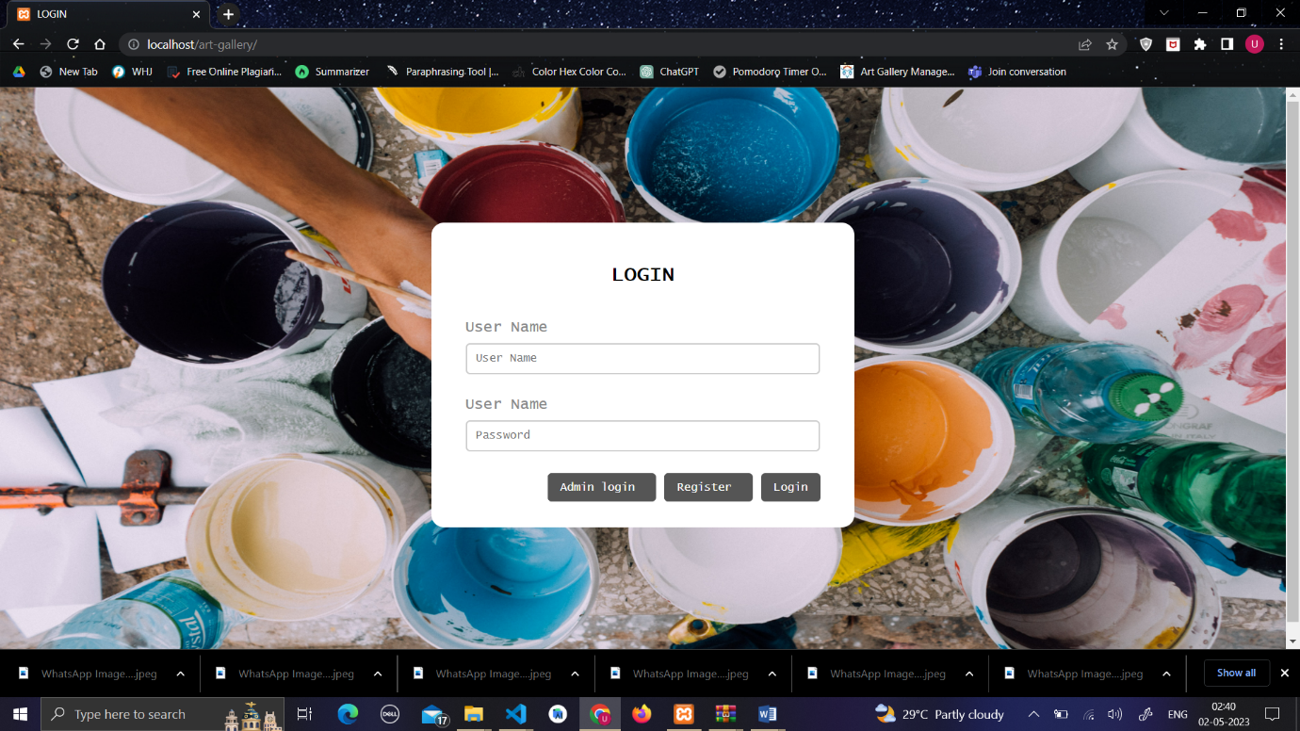

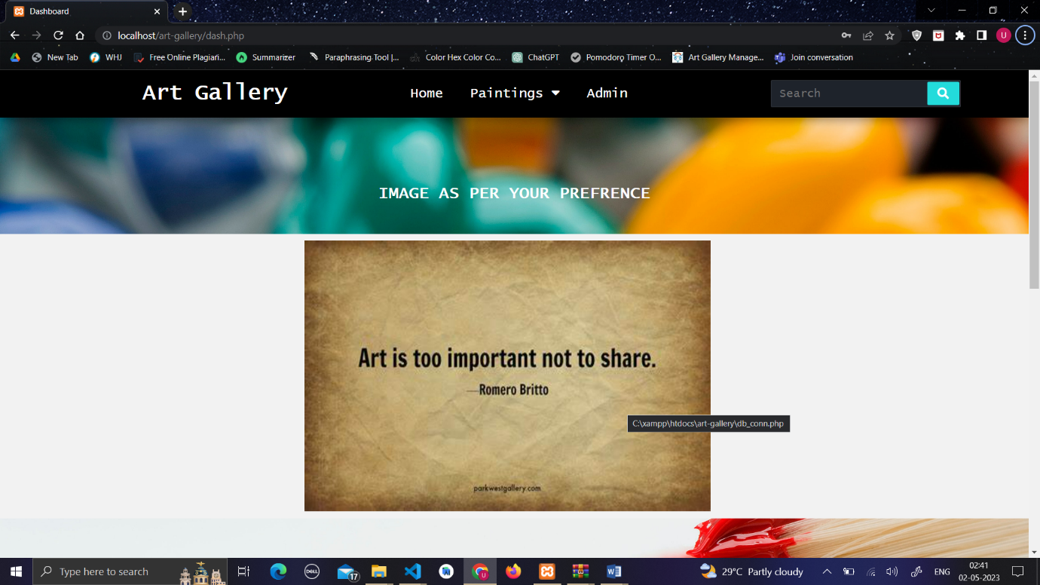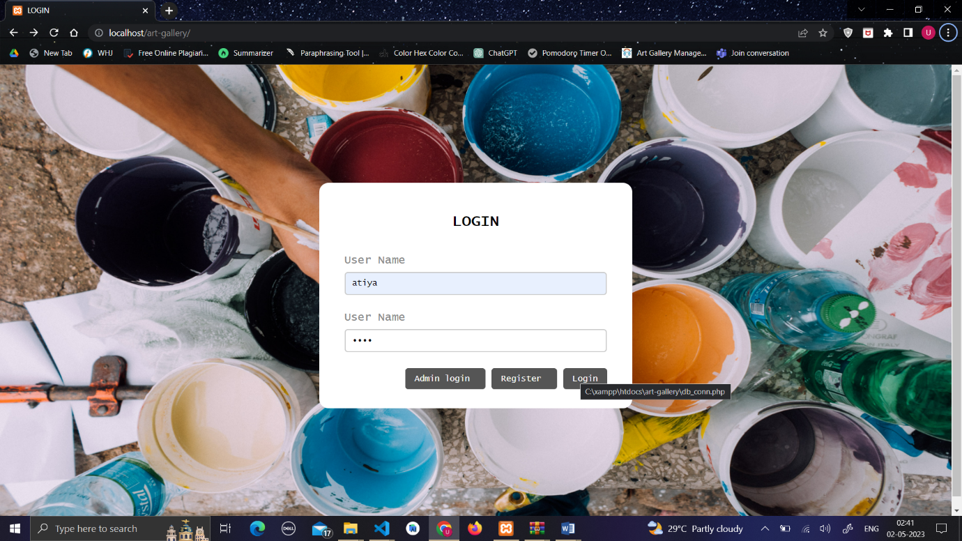

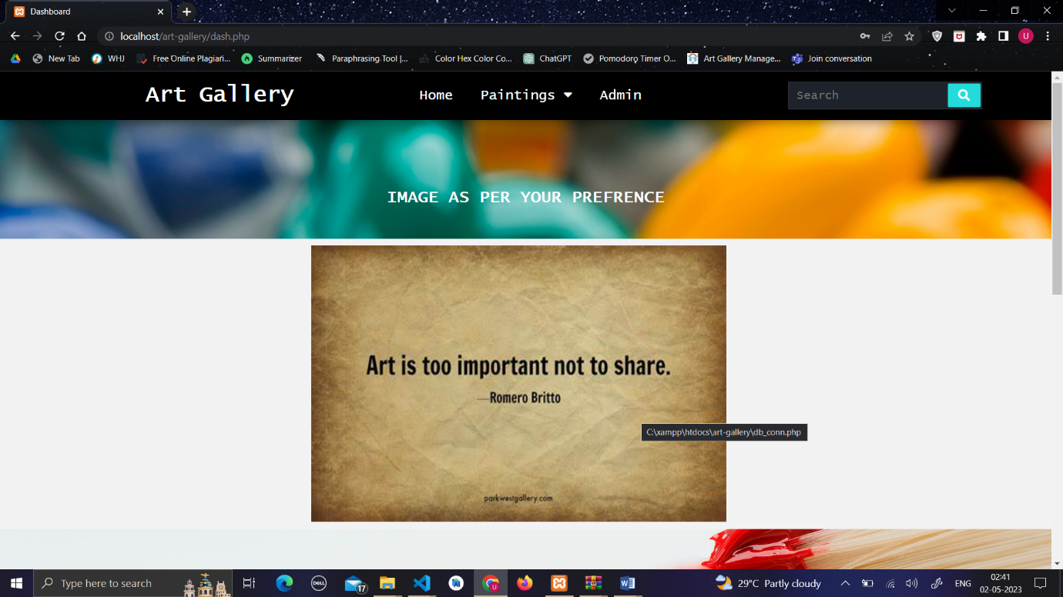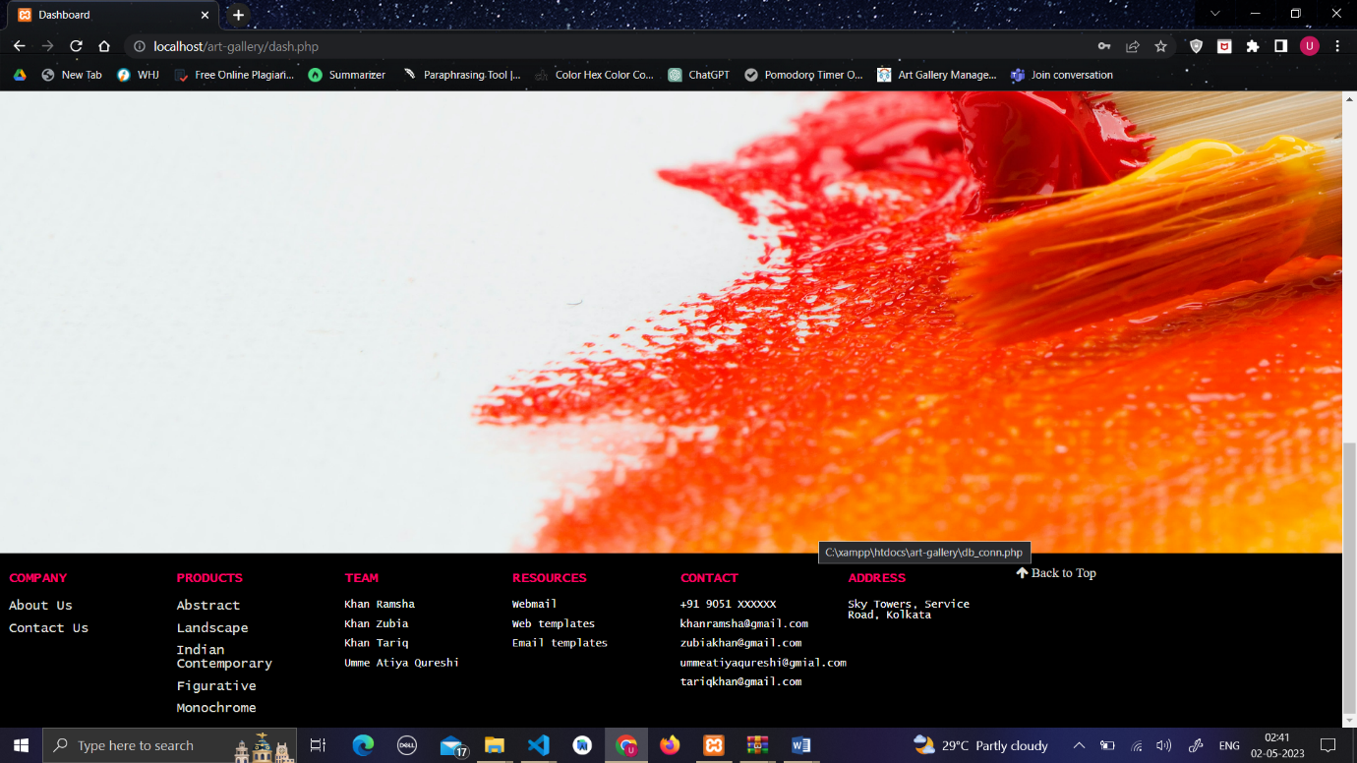

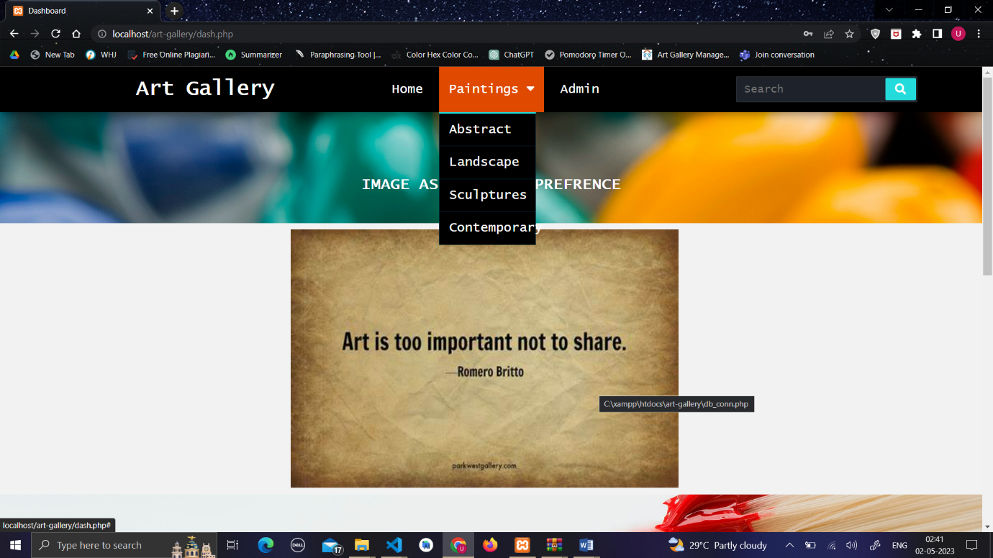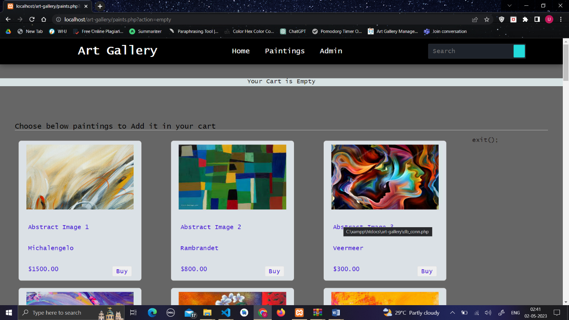

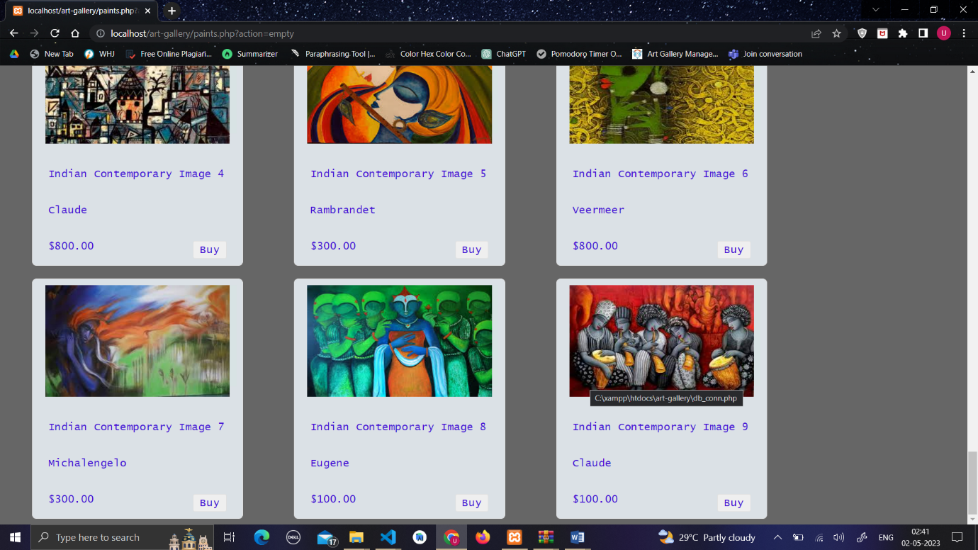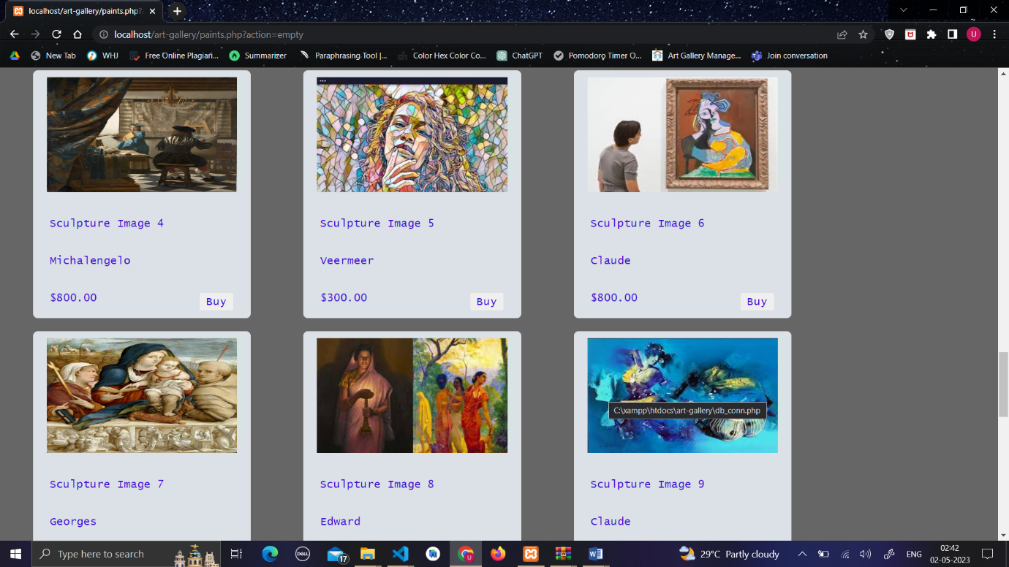

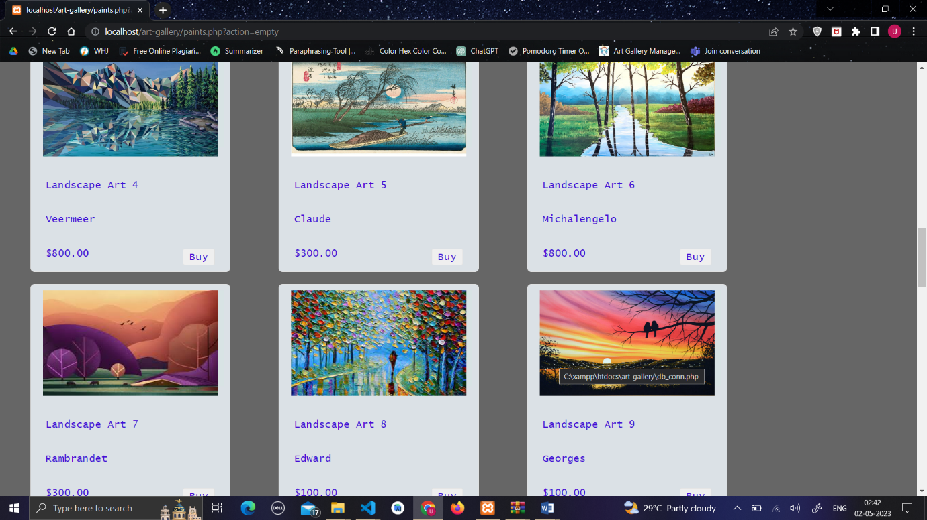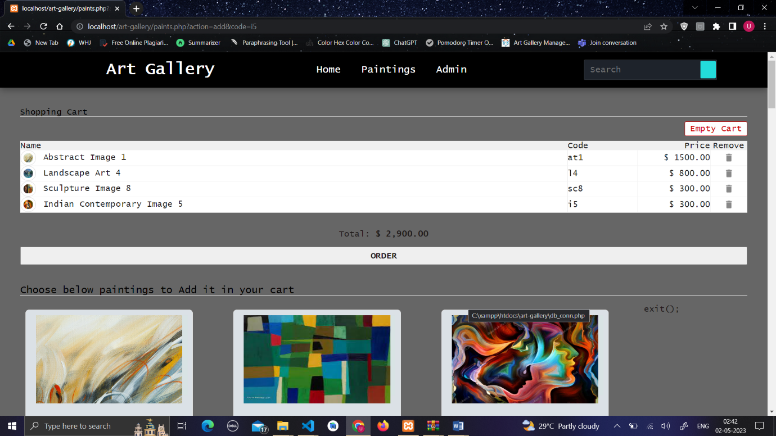

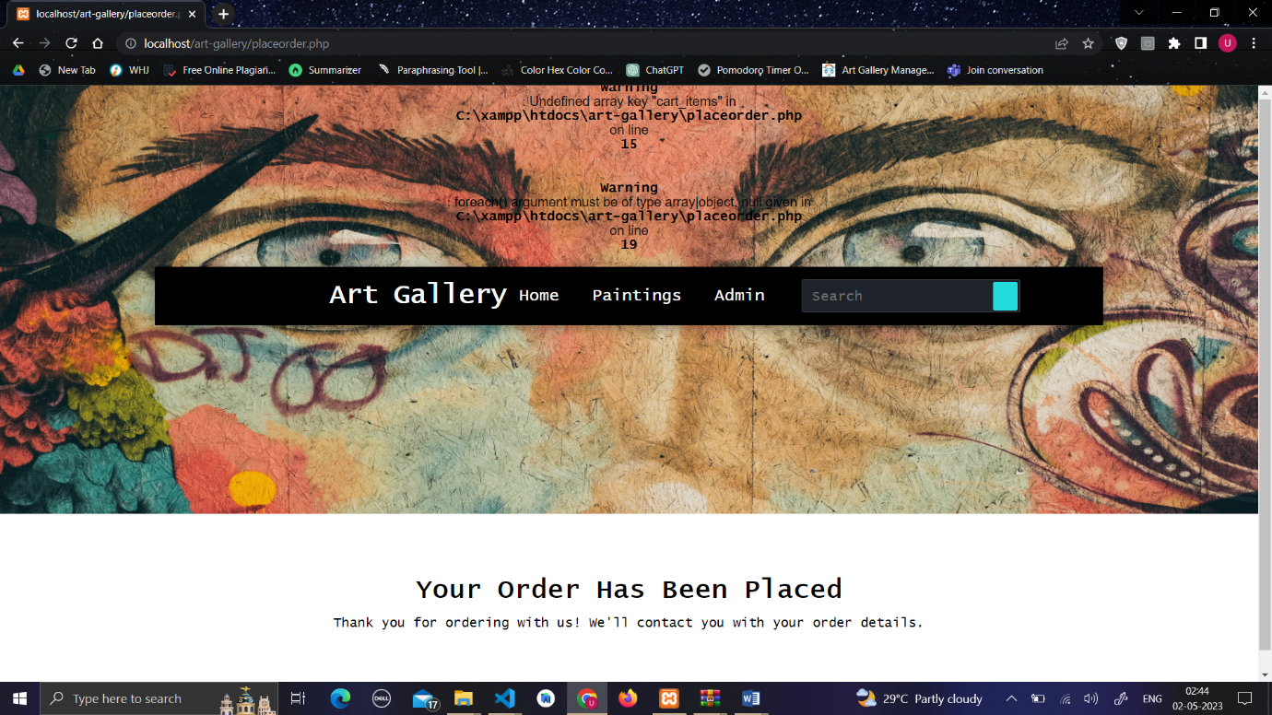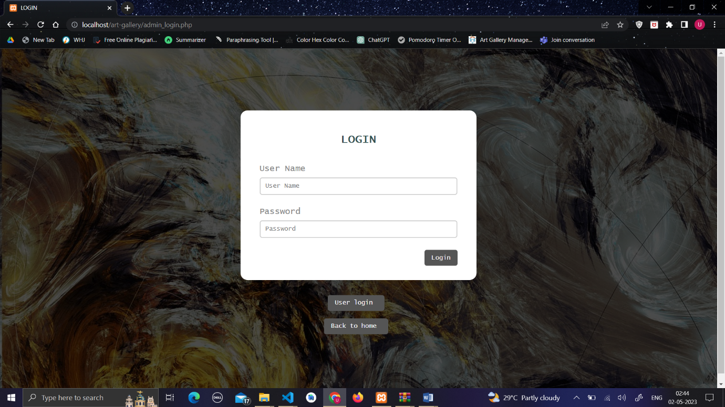

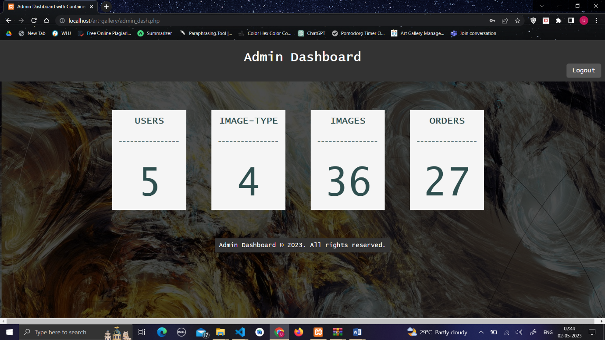

1. **Skills Developed / Learning outcome of this Micro-Project:**

The following skills are developed:

1) Identifying: Identifying the problem and cause of problem in the area related and prepare project proposals before starting the project.

2) Data Collection: Collect relevant data from different sources (books/the internet/the market/suppliers/experts and others through surveys/interviews).

3) Developing: Develop the prototype/model/ of the desired equipment/instrument/machine part etc.

4) Teamwork: Learn to work in a team and boost individual confidence.

5) Time Management: Timely completion of micro project as scheduled.

6) Data Analysis: Interpretation of data, drawing and analysis of laboratory calculations etc.

7) Technical Writing: Preparing a report of the proposed plan and final report.

8) Presentation and communication skills: Giving working model presentation of the micro project.

9) Confidence: Confidently, answer the questions asked about the project.

10) Acknowledgement: Acknowledge the help rendered by others in the success of the project.

1. **Applications of this Micro-Project:**

1. An art gallery management system can be a valuable tool for streamlining various aspects of running an art gallery. Here are some applications of an art gallery management system:

Artwork inventory management: The system can help maintain a comprehensive database of all artworks in the gallery's collection. It can store information such as the artist's name, title, medium, dimensions, provenance, and current location. This allows for easy tracking of artworks, minimizing the risk of loss or misplacement.

Sales and customer management: The system can handle the sales process, including recording sales transactions, generating invoices, and managing customer information. It can maintain a customer database with contact details, purchase history, and preferences, enabling personalized marketing and targeted promotions.

Exhibition planning and scheduling: The system can assist in planning and organizing exhibitions by managing the scheduling of artworks, exhibition spaces, and associated events. It can facilitate collaboration among curators, artists, and other stakeholders involved in the exhibition process.

Online presence and e-commerce: An art gallery management system can integrate with an online platform, enabling the gallery to showcase artworks, provide detailed descriptions and images, and facilitate online sales. This expands the gallery's reach and accessibility to a global audience.

Artwork loans and consignments: The system can handle the logistics of loaning artworks to other institutions or consigning artworks to external galleries or art fairs. It can track loan agreements, insurance details, transportation arrangements, and condition reports.

Financial management: The system can assist in financial tasks such as tracking expenses, generating financial reports, and managing budgets. It can automate processes like invoicing, payment tracking, and financial reconciliations, streamlining the gallery's financial operations.

Artwork conservation and maintenance: An art gallery management system can store detailed conservation records, including condition reports, treatment histories, and maintenance schedules for each artwork. This helps in preserving the artworks' integrity and planning conservation efforts effectively.

Analytics and reporting: The system can provide analytical tools and reporting capabilities to analyze sales data, visitor demographics, and exhibition performance. This information can aid in making informed decisions regarding marketing strategies, exhibition planning, and resource allocation.

Communication and collaboration: The system can serve as a centralized platform for internal communication among gallery staff, allowing for efficient collaboration on projects, sharing information, and assigning tasks. It can also provide tools for communicating with artists, collectors, and other stakeholders.

Security and access control: An art gallery management system can incorporate security features such as access control, ensuring that only authorized personnel have access to sensitive information and restricted areas within the gallery.

These are just a few examples of how an art gallery management system can be applied. The specific features and functionalities may vary depending on the system's capabilities and the gallery's requirements.

(To be evaluated by the concerned teacher)

**Student name:** Khan Ramsha

**Roll no:** 20427

Day: 1 Duration : 2hr

Today, Ma’am instructed us to form groups of students for the micro- project, and specified that the group strength should be 4 or 5 students. And told us to search the micro-project topic, the topic should be industry application based, internet-based, workshop-based, laboratory-based or field-based. And told that the micro-project should encompass two or more Cos which are in fact, an integration of Pros, UOs, and ADOs. She also told that each group member will have to maintain a dated diary consisting of individual contribution in the project work and give a seminar presentation of it before submission. The total duration of the micro-project should not be less than 16 student engagement hours during the course. And the micro-project should be submitted before the end of the semester to develop the industry oriented Cos.

Following are my team-members:

1. (20427) Khan Ramsha.

2. (20428) Khan Tariq.

3. (20429) Khan Zubia.

4. (20438) Qureshi Umme Atiya.

Day: 2 Duration : 2hr

Today, we decided “Art Gallery Management System” as our micro-project topic. Ma’am instructed as the contents of the report and told us to collect information from various sources such as Internet and many more.

Day: 3 Duration : 2hr

Today, we started to collect information from the internet that we needed for our report. We went through various websites and collected all the information we needed to prepare our report. We decided to create the report in the next week and collect more information from the internet.

Day: 4 Duration : 2hr

As we collected all the required information from the internet, we opted to start with the report work. We divided the report contents among us.

Day: 5 Duration : 2hr

We started to create the report on our assigned topic. We made use of the information that we collected from the internet. We finished our work and checked whether the topic contains enough amount of information. We then combined all the topics and made our final report.

Day: 6 Duration : 2hr

Today, Ma’am checked our report and told us to make some changes. After making all the changes, we re-corrected our report from our guide. She told us to submit our report next week with presentation.

Day: 7 Duration : 2hr

Today, we submitted our micro-project and gave presentation on our topic. Ma’am asked us many question related to the completion of the project. Making such project increases our confidence and improves our command over the subject.

**Student name:** Khan Tariq

**Roll no:** 20428

Day: 1 Duration : 2hr

Today, Ma’am instructed us to form groups of students for the micro- project, and specified that the group strength should be 4 or 5 students. And told us to search the micro-project topic, the topic should be industry application based, internet-based, workshop-based, laboratory-based or field-based. And told that the micro-project should encompass two or more Cos which are in fact, an integration of Pros, UOs, and ADOs. She also told that each group member will have to maintain a dated diary consisting of individual contribution in the project work and give a seminar presentation of it before submission. The total duration of the micro-project should not be less than 16 student engagement hours during the course. And the micro-project should be submitted before the end of the semester to develop the industry oriented Cos.

Following are my team-members:

1. (20427) Khan Ramsha.

2. (20428) Khan Tariq.

3. (20429) Khan Zubia.

4. (20438) Qureshi Umme Atiya.

Day: 2 Duration : 2hr

Today, we decided “Art Gallery Management System” as our micro-project topic. Ma’am instructed as the contents of the report and told us to collect information from various sources such as Internet and many more.

Day: 3 Duration : 2hr

Today, we started to collect information from the internet that we needed for our report. We went through various websites and collected all the information we needed to prepare our report. We decided to create the report in the next week and collect more information from the internet.

Day: 4 Duration : 2hr

As we collected all the required information from the internet, we opted to start with the report work. We divided the report contents among us.

Day: 5 Duration : 2hr

We started to create the report on our assigned topic. We made use of the information that we collected from the internet. We finished our work and checked whether the topic contains enough amount of information. We then combined all the topics and made our final report.

Day: 6 Duration : 2hr

Today, Ma’am checked our report and told us to make some changes. After making all the changes, we re-corrected our report from our guide. She told us to submit our report next week with presentation.

Day: 7 Duration : 2hr

Today, we submitted our micro-project and gave presentation on our topic. Ma’am asked us many question related to the completion of the project. Making such project increases our confidence and improves our command over the subject.

**Student name:** Khan Zubia

**Roll no:** 20429

Day: 1 Duration : 2hr

Today, Ma’am instructed us to form groups of students for the micro- project, and specified that the group strength should be 4 or 5 students. And told us to search the micro-project topic, the topic should be industry application based, internet-based, workshop-based, laboratory-based or field-based. And told that the micro-project should encompass two or more Cos which are in fact, an integration of Pros, UOs, and ADOs. She also told that each group member will have to maintain a dated diary consisting of individual contribution in the project work and give a seminar presentation of it before submission. The total duration of the micro-project should not be less than 16 student engagement hours during the course. And the micro-project should be submitted before the end of the semester to develop the industry oriented Cos.

Following are my team-members:

1. (20427) Khan Ramsha.

2. (20428) Khan Tariq.

3. (20429) Khan Zubia.

4. (20438) Qureshi Umme Atiya.

Day: 2 Duration : 2hr

Today, we decided “Art Gallery Management System” as our micro-project topic. Ma’am instructed as the contents of the report and told us to collect information from various sources such as Internet and many more.

Day: 3 Duration : 2hr

Today, we started to collect information from the internet that we needed for our report. We went through various websites and collected all the information we needed to prepare our report. We decided to create the report in the next week and collect more information from the internet.

Day: 4 Duration : 2hr

As we collected all the required information from the internet, we opted to start with the report work. We divided the report contents among us.

Day: 5 Duration : 2hr

We started to create the report on our assigned topic. We made use of the information that we collected from the internet. We finished our work and checked whether the topic contains enough amount of information. We then combined all the topics and made our final report.

Day: 6 Duration : 2hr

Today, Ma’am checked our report and told us to make some changes. After making all the changes, we re-corrected our report from our guide. She told us to submit our report next week with presentation.

Day: 7 Duration : 2hr

Today, we submitted our micro-project and gave presentation on our topic. Ma’am asked us many question related to the completion of the project. Making such project increases our confidence and improves our command over the subject.

**Student name:** Umme Atiya Quraishi

**Roll no:** 20438

Day: 1 Duration : 2hr

Today, Ma’am instructed us to form groups of students for the micro- project, and specified that the group strength should be 4 or 5 students. And told us to search the micro-project topic, the topic should be industry application based, internet-based, workshop-based, laboratory-based or field-based. And told that the micro-project should encompass two or more Cos which are in fact, an integration of Pros, UOs, and ADOs. She also told that each group member will have to maintain a dated diary consisting of individual contribution in the project work and give a seminar presentation of it before submission. The total duration of the micro-project should not be less than 16 student engagement hours during the course. And the micro-project should be submitted before the end of the semester to develop the industry oriented Cos.

Following are my team-members:

1. (20427) Khan Ramsha.

2. (20428) Khan Tariq.

3. (20429) Khan Zubia.

4. (20438) Qureshi Umme Atiya.

Day: 2 Duration : 2hr

Today, we decided “Art Gallery Management System” as our micro-project topic. Ma’am instructed as the contents of the report and told us to collect information from various sources such as Internet and many more.

Day: 3 Duration : 2hr

Today, we started to collect information from the internet that we needed for our report. We went through various websites and collected all the information we needed to prepare our report. We decided to create the report in the next week and collect more information from the internet.

Day: 4 Duration : 2hr

As we collected all the required information from the internet, we opted to start with the report work. We divided the report contents among us.

Day: 5 Duration : 2hr

We started to create the report on our assigned topic. We made use of the information that we collected from the internet. We finished our work and checked whether the topic contains enough amount of information. We then combined all the topics and made our final report.

Day: 6 Duration : 2hr

Today, Ma’am checked our report and told us to make some changes. After making all the changes, we re-corrected our report from our guide. She told us to submit our report next week with presentation.

Day: 7 Duration : 2hr

Today, we submitted our micro-project and gave presentation on our topic. Ma’am asked us many question related to the completion of the project. Making such project increases our confidence and improves our command over the subject.

**Annexure IV**

**Micro Project Evaluation Sheet**

**Name of Student:** Khan Ramsha **Enrollment No:** 2000020195

**Name of Programme:** Computer(CO) **Semester:** VI

**Course Title:** Web Based Programming **Code:** 22619

**Title of the Micro-Project:** Art Gallery Management System.

### **Course Outcomes Achieved: -**

a) Develop program using control statement.

b) Perform operations based on arrays and graphics.

c) Develop programs by applying various object oriented concepts.

d) Use form controls with validation to collect user's input.

e) Perform database operations in PHP.

|  |  |  |  |  |  |  |
| --- | --- | --- | --- | --- | --- | --- |
| **Sr. No.** | **Characteristics to be assessed** | **Poor (Marks 1** - **3)** | **Average (Marks 4** - **5)** | **Good**  **(Marks 6** - **8)** | **Excellent (Marks 9- 10)** | **Sub Total** |
| (A) Process and Product Assessment (Convert above total marks out of 6 Marks) | | | | | |  |
| 1 | Relevance to the course |  |  |  |  |  |
| 2 | Literature Review/information collection |  |  |  |  |
| 3 | Completion of the Target as per project proposal |  |  |  |  |
| 4 | Analysis of Data and representation |  |  |  |  |
| 5 | Quality of Prototype/Model |  |  |  |  |
| 6 | Report Preparation |  |  |  |  |
| (B) Individual Presentation/ Viva (Convert above total marks out of 4 Marks) | | | | | |  |
| 7 | Presentation |  |  |  |  |  |
| 8 | Viva |  |  |  |  |

|  |  |  |
| --- | --- | --- |
| **(A)**  **Process and Product Assessment (6 marks)** | **(B)**  **Individual Presentation & viva (4 marks)** | **Total Marks**  **10** |
|  |  |  |

**Comments/Suggestions about teamwork/leadership/inter-personal communication (if any)**

**………………………………………………………………………………………………**

**Name and designation of the Teacher: Mr. Mohammed Zaid**

**Dated Signature** ……………………………………

**Annexure IV**

**Micro Project Evaluation Sheet**

**Name of Student:** Khan Tariq **Enrollment No:** 2000020197

**Name of Programme:** Computer(CO) **Semester:** VI

**Course Title:** Web Based Programming **Code:** 22619

**Title of the Micro-Project:** Art Gallery Management System.

### **Course Outcomes Achieved: -**

a) Develop program using control statement.

b) Perform operations based on arrays and graphics.

c) Develop programs by applying various object oriented concepts.

d) Use form controls with validation to collect user's input.

e) Perform database operations in PHP.

|  |  |  |  |  |  |  |
| --- | --- | --- | --- | --- | --- | --- |
| **Sr. No.** | **Characteristics to be assessed** | **Poor (Marks 1** - **3)** | **Average (Marks 4** - **5)** | **Good**  **(Marks 6** - **8)** | **Excellent (Marks 9- 10)** | **Sub Total** |
| (A) Process and Product Assessment (Convert above total marks out of 6 Marks) | | | | | |  |
| 1 | Relevance to the course |  |  |  |  |  |
| 2 | Literature Review/information collection |  |  |  |  |
| 3 | Completion of the Target as per project proposal |  |  |  |  |
| 4 | Analysis of Data and representation |  |  |  |  |
| 5 | Quality of Prototype/Model |  |  |  |  |
| 6 | Report Preparation |  |  |  |  |
| (B) Individual Presentation/ Viva (Convert above total marks out of 4 Marks) | | | | | |  |
| 7 | Presentation |  |  |  |  |  |
| 8 | Viva |  |  |  |  |

|  |  |  |
| --- | --- | --- |
| **(A)**  **Process and Product Assessment (6 marks)** | **(B)**  **Individual Presentation & viva (4 marks)** | **Total Marks**  **10** |
|  |  |  |

**Comments/Suggestions about teamwork/leadership/inter-personal communication (if any)**

**………………………………………………………………………………………………**

**Name and designation of the Teacher: Mr. Mohammed Zaid**

**Dated Signature** ……………………………………

**Annexure IV**

**Micro Project Evaluation Sheet**

**Name of Student:** Khan Zubia **Enrollment No:** 2000020199

**Name of Programme:** Computer(CO) **Semester:** VI

**Course Title:** Web Based Programming **Code:** 22619

**Title of the Micro-Project:** Art Gallery Management System.

### **Course Outcomes Achieved: -**

a) Develop program using control statement.

b) Perform operations based on arrays and graphics.

c) Develop programs by applying various object oriented concepts.

d) Use form controls with validation to collect user's input.

e) Perform database operations in PHP.

|  |  |  |  |  |  |  |
| --- | --- | --- | --- | --- | --- | --- |
| **Sr. No.** | **Characteristics to be assessed** | **Poor (Marks 1** - **3)** | **Average (Marks 4** - **5)** | **Good**  **(Marks 6** - **8)** | **Excellent (Marks 9- 10)** | **Sub Total** |
| (A) Process and Product Assessment (Convert above total marks out of 6 Marks) | | | | | |  |
| 1 | Relevance to the course |  |  |  |  |  |
| 2 | Literature Review/information collection |  |  |  |  |
| 3 | Completion of the Target as per project proposal |  |  |  |  |
| 4 | Analysis of Data and representation |  |  |  |  |
| 5 | Quality of Prototype/Model |  |  |  |  |
| 6 | Report Preparation |  |  |  |  |
| (B) Individual Presentation/ Viva (Convert above total marks out of 4 Marks) | | | | | |  |
| 7 | Presentation |  |  |  |  |  |
| 8 | Viva |  |  |  |  |

|  |  |  |
| --- | --- | --- |
| **(A)**  **Process and Product Assessment (6 marks)** | **(B)**  **Individual Presentation & viva (4 marks)** | **Total Marks**  **10** |
|  |  |  |

**Comments/Suggestions about teamwork/leadership/inter-personal communication (if any)**

**………………………………………………………………………………………………**

**Name and designation of the Teacher: Mr. Mohammed Zaid**

**Dated Signature** ……………………………………

**Annexure IV**

**Micro Project Evaluation Sheet**

**Name of Student:** Qureshi Umme Atiya **Enrollment No:** 2000020196

**Name of Programme:** Computer(CO) **Semester:** VI

**Course Title:** Web Based Programming **Code:** 22619

**Title of the Micro-Project:** Art Gallery Management System.

### **Course Outcomes Achieved: -**

a) Develop program using control statement.

b) Perform operations based on arrays and graphics.

c) Develop programs by applying various object oriented concepts.

d) Use form controls with validation to collect user's input.

e) Perform database operations in PHP.

|  |  |  |  |  |  |  |
| --- | --- | --- | --- | --- | --- | --- |
| **Sr. No.** | **Characteristics to be assessed** | **Poor (Marks 1** - **3)** | **Average (Marks 4** - **5)** | **Good**  **(Marks 6** - **8)** | **Excellent (Marks 9- 10)** | **Sub Total** |
| (A) Process and Product Assessment (Convert above total marks out of 6 Marks) | | | | | |  |
| 1 | Relevance to the course |  |  |  |  |  |
| 2 | Literature Review/information collection |  |  |  |  |
| 3 | Completion of the Target as per project proposal |  |  |  |  |
| 4 | Analysis of Data and representation |  |  |  |  |
| 5 | Quality of Prototype/Model |  |  |  |  |
| 6 | Report Preparation |  |  |  |  |
| (B) Individual Presentation/ Viva (Convert above total marks out of 4 Marks) | | | | | |  |
| 7 | Presentation |  |  |  |  |  |
| 8 | Viva |  |  |  |  |

|  |  |  |
| --- | --- | --- |
| **(A)**  **Process and Product Assessment (6 marks)** | **(B)**  **Individual Presentation & viva (4 marks)** | **Total Marks**  **10** |
|  |  |  |

**Comments/Suggestions about teamwork/leadership/inter-personal communication (if any)**

**………………………………………………………………………………………………**

**Name and designation of the Teacher: Mr. Mohammed Zaid**

**Dated Signature** ……………………………………